ASSESSMENT OF FACTORS AFFECTING THE LEVEL OF CONSUMER AWARENESS TO THEIR RIGHTS AND PROTECTION OF FAST-MOVING CONSUMER GOODS SECTOR IN NAIROBI, KENYA

BY
SAMUEL M GITAU
Aipms/240/2019

A research thesis submitted to Africa Institute for Project Management Studies (AIPMS) College, in partial fulfillment of the requirements for the Diploma in Procurement and Supply Chain Management.

August 2019
DECLARATION

Declaration by the Candidate
This research thesis is my original work and all materials which are not my own have been cited and acknowledged. The work has not been presented for a diploma in any other College.

Signed: ……………………………… Date: ……………………

This research thesis has been submitted for examination with my approval as College Supervisor

Signed…………………………… Date: ……………………………….

DEDICATION
This research thesis is dedicated to my Wife and Children for their endless support morally and spiritually during my research studies.

ACKNOWLEDGEMENT
I wish to extend my sincere gratitude to my Student support team at Africa Institute for Project Management Studies. They really empowered me academically, socially and morally. This research project is a product of my effort. Special thanks to my supervisor, whose professional advice, guidance and moral assistance was of immense help. And above all almighty God who granted me good health throughout my studies.

ABSTRACT
In many emerging economies and developing countries, the promotion of consumers’ rights to develop a consumer-oriented culture remains a very big challenge. Without understanding the level of consumer awareness to their rights and protection, it would be difficult to develop appropriate policies and strategies to ensure that consumers are always satisfied with goods and services they purchase. The objective of the study was to determine the level of awareness to consumer rights and protection and determine the factors that affect the level of awareness to their consumer rights, consumer protection agencies and available redress mechanisms in Nairobi, Kenya. The data was collected from 379 consumers who were selected using stratified random sampling technique. The sample size was determined using proportional sampling method. Data collection was done by randomly administering structured questionnaires to respondents. The demographic characteristics were analyzed using descriptive statistics and results show that 54.5% of consumers are aware of their rights, 81% are aware of consumer protection agencies and 46% are aware of available redress mechanisms in Nairobi. The probit results show that awareness to consumer rights is associated with some demographic characteristics such gender, education and income. Education level of the consumers significantly contribute in enhancing the extent of awareness regarding consumer protection agencies. Education level and income of the consumers significantly contribute in enhancing the extent of awareness to available redress mechanisms. The study concludes by giving appropriate recommendations to enhance consumer education on their rights, consumer protection agencies and redress mechanisms as well as suggestions for future research.

TABLE OF CONTENTS
DECLARATION ii
DEDICATION iii
ACKNOWLEDGEMENT iv
ABSTRACT v
INTRODUCTION 1
1.1 Background 1
1.2 Problem Statement 2
1.3 Main Research Objectives 3
1.3.1 Specific Research Objectives 4
1.4 Research Questions 4
1.5 Scope of the Study 4
1.6 Significance of the Study 5
1.7 Constraints of the Research 5
1.8 Outline of the Study 5
CHAPTER TWO 6
LITERATURE REVIEW 6
2.1 Introduction 6
2.2 Definition of Consumers 6
2.3 Consumer Rights 7
2.4 Consumer Issues in FMCG Sector 8
2.5 Consumer Protection Laws 10
2.6 Consumer Protection Organizations/Agencies/Institutions 12
2.7 Available redress mechanisms 13
2.8 Awareness on consumer rights and protection 16
2.9 Factors that Influence consumer awareness to their rights and protection 18
2.9.1 Demographic factors that affect awareness on consumer rights 18
2.9.2 Factors that affect the level of awareness to redress mechanisms. 21
2.9.3 Demographic factors that affect the level of awareness to Consumer Protection organizations/agencies/institutions. 23
2.10 Discussion of Gaps in Literature 24
2.11 Conceptual Framework 24
2.12 Hypotheses of the Study 26
CHAPTER THREE 27
RESEARCH METHODOLOGY 27
3.1 Introduction 27
3.2 Research Design 27
3.3 Population and Target Sample 27
3.4 Sampling method 28
3.5 Sample Size 28
3.6 Data Collection Tools and Procedure 29
3.7 Data Analysis and Presentation 30
3.7.1 Data entry and Cleaning 30
3.7.2 Data Coding 30
3.7.3 Statistical Analysis 30
3.7.4 Analytical model 30
Variables 32
3.8 Validity and Reliability 35
3.9 Ethical Considerations 36
RESULTS AND DISCUSSION 37
4.1 Introduction 37
4.2 Response rate 37
4.3 Demographic characteristics 37
4.4 Awareness Level 38
4.4.1 Level of awareness to consumer rights 39
4.4.2 Level of awareness to consumer protection agencies 41
4.4.3 Level of awareness to available redress mechanisms 43
4.5 Relationship between awareness level and demographic characteristics 48
4.5.1 Gender and level of awareness 48
4.5.2 Income and level of awareness 49
4.5.1 Highest level of education and level of awareness 51
4.5.1 Age and level of awareness 52
4.6 Probit regression Results 54
4.6.1 Impact of demographic factors on level of awareness to consumer rights 54
4.6.2 Probit analysis of impact of demographic factors on level of awareness to consumer protection agencies 56
4.6.3 Probit analysis of impact of demographic factors on level of awareness to available redress mechanisms 57
CHAPTER FIVE 59
CONCLUSIONs AND RECOMMENDATIONS 59
5.1 Introduction 59
5.2 Conclusion 59
5.3 Recommendations 60
5.4 Suggestions for Further Research 61
REFERENCES 62
APPENDICES 68
Appendix A: Survey Questionnaire for Consumers: 68
Appendix B: Letter of Authorization 76

LIST OF TABLES
Table 3.5-1: Sample size distribution 29
Table 3.8-1: Reliability statistics of pilot study 36
Table 4.3-1: Demographic information 37
Table 4.5-1: Results of difference of means (gender) 49
Table 4.5-2: Results of difference of means (Income level) 50
Table 4.5-3: Results of difference of means (Education level) 51
Table 4.5-4: Results of difference of means (Age) 53
Table 4.6-1: Probit regression results for effect of demographic factors on level of awareness to consumer rights. 54
Table 4.6-2: Probit regression results for effects of demographic factors on awareness to consumer protection agencies 56
Table 4.6-3: Probit regression results of effect of demographic factors on awareness to redress mechanisms 57

LIST OF FIGURES
Figure 2.11-1: Conceptual Framework 25
Figure 4.4-2: Most frequently mentioned consumer rights 40
Figure 4.4-3: Sources of information on consumer rights 40
Figure 4.4-4: Institutions/organizations dealing with consumer rights protection 42
Figure 4.4-5: Level of satisfaction with the Consumer protection agency 43
Figure 4.4-6: Level of consumer dissatisfaction 44
Figure 4.4-7: Dissatisfaction per product category 45
Figure 4-9: Action taken after dissatisfaction 46
Figure 4.4-10: Level consumer satisfaction with complaints to traders 47
Figure 4.5-1: Relationship between awareness level and gender 48
Figure 4.5-2: Relationship between awareness level and income level 49
Figure 4.5-3: Relationship between awareness level and education level 51
Figure 4.5-4: Relationship between awareness level and age 52
LIST OF ACRONYMS
ADR Alternative Dispute Resolution
BMDP Biomedical Medical Data Package
CIN Consumer Information Network
COFEK Consumer Federation of Kenya
CPA Consumers Protection Act
CP Consumer Protection
FMCGs Fast Moving Consumer Goods
KCO Kenya Consumer Organization
KEBS Kenya Bureau of Standards
KNBS Kenya National Bureau of Statistics
KPHC Kenya Population and Housing Census
MANOVA Multiple analysis of variance
NAFDAC National Food and Drug Administration and Control
NCWTO National Committee on World Trade Organization
OFGEM Office of gas and electricity markets
SPSS Statistical Package for Social Science
UN United Nations
CHAPTER ONE

INTRODUCTION

Background
Business is an integral part of current day society. Each company has a socio-economic impact to the people and must deliver the goods and services and the standard of living as per the aspirations of the people. Consumer is an important component of society and business has an obligation to him. Therefore, consumers need to be protected from unsafe products, poor quality of goods and services, high prices, unfair trade practices and misleading advertisements. It is necessary for consumer rights awareness to prevail among consumers to protect them from unscrupulous trade practices (Khan, 2013).
Fast moving consumer goods (FMCGs) constitute a large part of consumers’ budget in all countries. Cleaning and laundry products, over the counter medicine, personal care items and foodstuffs make up a large bulk of the goods in the FMCG arena. Retail trade in these products has attracted interest from consumers and policy-makers because a well-functioning retail sector is essential for provision of these essential products at low cost and high quality (Celen et al., 2005).
Prior to Kenya promulgating its constitution in 2010 and enacting the Consumer Protection Act in 2012, there were no specific laws dealing with consumer protection in Kenya. Consumer protection was covered in various legislation including the Trade Description Act, Monopolies and Price Control Act, the Foods, Drugs and Chemical Substances Act, the Pharmacy and Poisons Act, the Fertilizers and Animal Foodstuffs act, as well as private law of contract and the law of tort. These and other legislations touching on consumers are criminally oriented as they seek to ban one malpractice or the other and to prosecute offenders for breach of the law, but do not empower a consumer to sue the offender to get redress and/or compensation, where the said breach affects him or her adversely. It is in this regard that the Constitution of Kenya Article 46, 2010 and its enabling statute, the Consumer Protection Act, 2012 are lauded as landmark achievements in consumer protection. The laws spell out consumer’s rights and obligations vis-à-vis product and service liability and make provisions for the promotion and enforcement of consumer rights as well as empower consumers to seek redress for infringement of their rights as consumers and make provisions for compensation (Harney Advocates, 2012).

The main objective of the Consumer Protection Act, 2012, is to provide for the protection of consumers and reduce unfair trade practices in consumer transactions. The Act establishes the Consumers Protection Advisory Committee that shall aid in the formulation of policy related to consumer protection, accredit consumer organizations, advise consumers on their rights and responsibilities, investigate complaints and establish mechanisms for conflict resolution amongst other duties (Consumer protection Act, 2012).

Despite the existence of various laws on consumer issues and institutions that are mandated to protect consumers, awareness level among consumers on consumer rights and their protection is rather low in many developing countries. Inadequate sensitization of consumers about their rights and laws that protect those rights means that consumers will continue to be exposed to poor quality products, safety risks, among other undesirable effects. This, in turn, may lead to other negative outcomes such as unplanned expenditure on health by both the government and households and decreased labor productivity.
Awareness and lack of knowledge on consumer rights and available redress mechanisms potentially distort consumers’ capacity and ability to defend themselves against astute traders. Therefore, a thorough investigation is needed to determine the factors that affect the level of consumer awareness to their rights and protection in Nairobi, Kenya.

Problem Statement
The area of consumer protection is relatively new to most developing countries such as Malaysia Indonesia and Africa countries (Azrina, 2011). The journey towards stricter consumers’ protection via establishment of specific laws has recently emerged in a number of countries and in order to ensure effectiveness it requires collaboration, participation and coordination from all stakeholders, including the consumer (Ong & Sakina, 2011). Consumers play an important role as they must express their dissappointments or complaints before remedies can be taken (Donoghue & De Klerk, 2009). The intense emphasis on private sector led development, the increasing wave of globalization and unprecedented growth in information and communication technology among others have all combined to reawaken interest in consumers’ rights and protection. This resurgence is not restricted to the developing countries but has been shown to be prevalent in the highly developed democracies of the world (Nkamnebe et al., 2009).
As the consumer movement in Africa gains momentum and African countries become commercially more integrated, investigation of the applicability of consumer awareness becomes paramount. Many researchers have argued for cross-cultural research that attempts to establish the generalizability of various theoretical relationships (Lee & Green 1991, Netemeyer et al., 1991).

In many developing countries such as Malaysia, Indonesia, and those in Africa, consumers are reluctant to complain to the concerned regulatory bodies. This may be due to lack of awareness of their rights or consumers may not know the relevant bodies that should be approached to complain, as well as the regulations that govern the transactions (Ishak & Zabil, 2012).
Although the existing literature has provided great insights on consumer rights and protection approaches in other countries, there are areas that are underdeveloped and calls for further research. Existing research has covered consumer protection awareness in various countries and on sectors like the financial sector and medical sector. Their is limited research focusing on the FMCG sector in Kenya. One of the objectives of this study is to measure the level of awareness to consumer rights and protection and determine the factors that affect the level of awareness, a focus on FMCG sector in Nairobi, Kenya. The proposed study will fill the existing gap in the literature by focusing on the FMCG due to their higher vulnerability/susceptibility to abuse owing to their day-to-day use and application by the general population.

Main Research Objectives
The main objective of the study was to determine the level of awareness on consumer rights, consumer protection institutions and awareness to available redress mechanisms and examine the factors that influence the awareness levels among consumers in Nairobi, Kenya with a focus on fast moving consumer goods sector.

Specific Research Objectives
The specific objectives of the study were:
- To investigate the levels of awareness to consumer rights, consumer protection agencies and available redress mechanisms in FMCG sector in Nairobi.
- To determine the effects of demographic factors on the level of awareness on consumer rights, consumer protection agencies and available redress about FMCGs in Nairobi, Kenya
- To make recommendations that can be used to enhance consumer awareness on their rights, consumer protection agencies and redress mechanisms.

Research Questions
The research questions explored in this study were:
- What are the levels of awareness on consumer rights, consumer protection agencies and available redress mechanisms among consumers in Nairobi County?
- Do demographic characteristics affect awareness to consumer rights, consumer protection agencies and available redress mechanisms about FMCGs in Nairobi County?
- What recommendation(s) can be proposed to enhance consumer awareness on their rights and protection in Nairobi, Kenya?

Hypotheses of the Study
Based on the conceptual framework advanced above, it can be postulated that demographic characteristics may affect the level of awareness to consumer rights, consumer protection agencies and available redress mechanisms. This relationship can be hypothesized as shown below.

H_{1N} – Consumer awareness to their rights, consumer protection agencies and redress mechanisms is lower in developing countries
H_{1A} – Consumer awareness to their rights, consumer protection agencies and redress mechanisms is higher in developing countries

H_{2N}: Demographic characteristics significantly do not affect the level of awareness to consumer rights, consumer protection organizations and awareness to redress mechanisms
H_{2A}: Demographic characteristics significantly affect the level of awareness to consumer rights, consumer protection organizations and awareness to redress mechanisms.

Scope of the Study
The study sought to investigate the extent to which consumers in Nairobi are aware of their rights regarding purchases and consumption of various FMCG goods and the protection that has been put in place to safeguard the consumer rights, interests and wellbeing in the course of purchase and consumption.
The study focused on fast moving consumer goods (FMCG), due to their higher vulnerability or susceptibility to abuse owing to their day-to-day use and application by the general population. Other products such as pharmaceuticals, financial services, and horticultural products have an established and better communicated protection guidelines hence will not be covered by this study. Data collection will be via structured questionnaires (after obtaining written informed consent).

Significance of the Study
This research will contribute to the body of knowledge on consumer rights and protection awareness in the FMCG sector in Kenya. The findings from this study will contribute to existing literature on consumerism in Kenya and will also provide policy makers with empirical data on consumer protection awareness levels for appropriate intervention measures. The data generated can be used by manufacturers and traders to review their redress mechanisms which in turn will strengthen customer loyalty by addressing complaints about poor quality products; manufacturers will also get the opportunity to correct product problems, improve the quality of existing products and identify opportunities for innovations.

Constraints of the Research
If time had permitted, this research would have assessed the effects of other variables that possibly could have provided additional insight on the broader factors that affect the level of consumer awareness to their rights and protection.

Outline of the Study
This study is organized as follows: Chapter 1 provides a background to the study and builds a case for the research study in terms of why consumers should be aware of their rights and protection. This is followed by chapter 2 which provides an in-depth literature review on the definition of consumers and then moves to cover literature on consumer rights, consumer issues that are common among FMCG consumers, consumer protection laws and institutions that protect consumers and the steps that are available for consumers to seek redress to any complaints they have. The chapter progresses to discuss consumer complaints process and mechanisms manufacturers, suppliers or traders have put in place to address consumer complaints in Kenya and consumer awareness and the factors that influence consumer awareness. Chapter 3 outlines the research methodology, sample size, data collection and data analysis. Chapter 4 presents the results and discussions on demographic characteristics, awareness level and the associated test statistics. The study concludes with Chapter 5, which presents the conclusions and recommendations.

CHAPTER TWO

LITERATURE REVIEW

Introduction
In this chapter, we explore in literature on consumer rights and protection, institutions with the mandate to protect consumers, consumer issues in FMCG sector, consumer complaint process, consumer awareness and factors affecting consumer awareness.

Definition of Consumers
The Consumer Protection Act 2012, gives a wide definition of consumer to mean; a person to whom particular goods or services are marketed in the ordinary course of the supplier’s business; a person who has entered into a transaction with the supplier in the ordinary course of the supplier’s business, unless the transaction is exempt from the application of the Act; a user of particular goods or a recipient or beneficiary of particular services, irrespective of whether that user, recipient or beneficiary was a party to a transaction concerning the supply of those particular goods and services; and a franchisee in terms of a franchise agreement, to the extent applicable in terms of this Act.
A more comprehensive definition of the consumer is found in the Competition Act, 2012 as including any person who purchases or offers to purchase goods or services other than for the purpose of resale, but does not include a person who purchases any goods or services for the purpose of using them in the production or manufacture of any goods or articles for sale. This clearly differentiates a consumer consuming a commodity or service for his personal domestic use and one who uses it for his livelihood. Only consumers are protected as per this Act and any person, entity or organization purchasing a commodity for commercial reasons does not fall under this purview.
By reasonable man standard we are inclined to presuppose that using the phrase “a person” the legislator intended to include and protect both natural and artificial persons. To note, the statutory definition of the “consumer” encapsulates both a contractual and a non-contractual as evidenced in the CPA which talks about a user, recipient or beneficiary or a franchisee as well as a person who has entered into a transaction. The Black’s Law Dictionary adopts a definition like that of the statute but limits it to the natural person (Black, 2009).

Consumer Rights
Consumer rights are an integral part of our lives like the consumerist way of life. We have all made use of them at some point in our daily lives. Market resources and influences are growing by the day and so is the awareness of one’s consumer rights. These rights are well defined and there are agencies like the government, consumer courts and voluntary organizations that safeguard the rights of consumers. While we like to know about our rights and make full use of them, consumer responsibility is an area which is still not demarcated and it is hard to spell out the responsibility that a consumer is supposed to shoulder (Chaudhry, 2011).
The Kenya 2010 constitution entrenched the right to consumer protection, that is, consumers should be protected from unfair market practices from services and goods providers. The constitution of Kenya, 2010 article 46 provides that: Consumers have the right to goods and services of reasonable quality; to the information necessary for them to gain full benefit from goods and services; to the protection of their health, safety and economic interests; and to compensation for loss or injury arising from defects in goods and services. It also states that Parliament shall enact legislation to provide for consumer protection and for fair, honest and decent advertising.
The right to information is defined as the ‘the right to be informed about the quality, quantity, potency, purity, standard and price of goods or services, to protect the consumer against unfair trade practices. In the Indian market place, consumers get consumer information through two popular, yet unreliable means, namely advertising and word of mouth. Due to this, the consumers in India seldom have accurate and complete information to assess the true value, suitability, safety or reliability of any product. Mostly we find out hidden costs, lack of suitability, safety hazards and quality problems only after they have purchased the product (Khan, 2013).
The right to representation (to be heard) means the right to advocate consumers’ interests with a view to receiving full and sympathetic consideration in the formulation and execution of economic and other policies, which affect consumers. The UN Guidelines suggest various measures with respect to the right to representation. Firstly, governments should facilitate the development of independent consumer groups. Secondly, opportunities are to be provided to consumer groups for presenting their views in the decision-making processes. This right is supposed to empower consumers to fearlessly voice their complaints and concerns against products and companies to ensure their issues are handled efficiently and expeditiously (United Nations, 2003).
The rationale behind the right to healthy environment is that the resources used in the production and consumption of goods and services should be utilized in a healthy and ecologically sound manner. As per the guidelines, governments should adopt measures relating to use, production and storage of pesticides and chemicals. The guidelines have now been revised to include guidelines for sustainable consumption. The elaborate mention of these in the Guidelines now lists out both the rights and responsibilities of the consumer (United Nations, 2003).
This research will focus on the consumer rights related to sale of FMCG goods: the right to be educated about consumer rights, the right to seek redress, the right to be informed about the quality, quantity, potency, purity, standard and price of goods or services, rights to safe products and the rights to representation.

Consumer Issues in FMCG Sector
Fast moving consumer goods (FMCGs) can be defined as packed goods that are consumed or sold at regular and small intervals (Nagarajan & Sheriff, 2013). The prices of FMCG goods are relatively low and profits earned through such sales are more volume based. FMCG products include toiletries, soaps, detergents, cleaning and disinfecting agents, cosmetics, non-durables and pharmaceuticals. Packed food products and drinks are also classified under FMCG since these items are consumed or bought at regular intervals. Electronic items like mobile phones, MP3 players and external hard drives among others have also been brought under the gamut of FMCG sector (Nagarajan & Sheriff, 2013).
Consumers experience various issues with FMCG products and some of the issues include product safety, product quality, service quality, warranties, service treatment and substandard products just to name a few. A safe product is one that does not affect negatively the health and safety of persons, considering its characteristics and presentation, a product should be regarded as defective if it does not comply with the standard of reasonable safety that a person is entitled to expect of it (Yee-Man & Wong, 2002). Where a product is unsafe or has defects, a manufacturer may choose to recall it from the market. As Mackenzie and Evans (2010) assert, Toyota recalled 2.3 million vehicles because of a problem with the gas pedal. Five days later, Toyota announced it would stop the sale of all models affected by this recall (Choi & Chung, 2013).
Service quality gap relative to price is another major issue; according to Toncar et al. (2010), consumers may be more willing to accept price loss when service is good, or less willing to positively evaluate service quality when price loss occurs. On the breach of contracts and consumer warranties, there are instances where the warranties have not been adhered to and the customer is left with no recourse. A “Product warranty” in this case can be considered as a statement (written and/or oral) about the nature or quality of the product and its condition or what the warrantor (generally the manufacturer) will do if anything is or goes wrong with the product (Loomba, 1998).
The consumers’ concerns on product safety, quality and nutrition are increasingly becoming important around the world, which has provided opportunities for FMCG goods in the recent years. Rising affluence will drive growth for FMCG firms over the next several years. The aggregate demand for consumer goods has remained strong, and demand for soaps and cleansers is growing. Kenya’s rapidly-growing middle class, with annual household incomes of US $ 3000-5000 is becoming increasingly brand conscious and aware of the importance of personal grooming sector (Nagarajan & Sheriff, 2013) and therefore, an analysis of common consumer issues in the FMCG sector and analysis of the consumer awareness on how to seek redress is important for the growth of this sector.
Advertisements appeal to or create unnecessary wants; consumers have become skeptical about the usefulness and trustworthiness of information provided by commercial sources. Promotion of unrealistic or unsupportable expectations and exaggeration about performance of a product has made consumers skeptical of marketing. This factor is also identified by Kotler et al. (1998), cited in Quazi (2002: 36), who see questionable marketing and business practices as precipitating consumer dissatisfaction.

Consumer Protection Laws
Consumer protection laws are designed to ensure fair trade competition and the free flow of truthful information to the marketplace. The laws are designed to prevent businesses that engage in fraud or specified unfair practices from gaining an advantage over competitors and may provide additional protection for the weak and those unable to take care of themselves. Consumer Protection laws are a form of government regulation which aim to protect the rights of consumers (Chaudhry, 2011).
Prior to Kenya's attainment of self-rule in June 1963, the degree of industrialization and monetization of the economy was low. Most consumer items such as sugar, fats, razor blades, and farming implements which were needed by the settler community were imported from U.K. The interests of the settlers were protected through the Price Control Act of 16th October 1956 to ensure that consumers of essential goods and services were not exploited. On attainment of independence, Kenya embarked on a process of rapid industrialization and indigenization of the economy through the setting up of import substitution industries to meet local and East African Community requirements. The government enacted the Trade Licensing Act, Cap. 497 which legalized the take-over of non-citizen firms by Kenyans through denial of trade licenses for certain trades and businesses. The government also controlled imports and exports through the Imports, Exports and Essential Supplies Act, Cap.502 (Ministry of Trade, 2014).
Chaudhry (2011) researched on consumer protection and consumerism in India and concluded that consumers are exploited, more so in a developing country with the prevalence of mass poverty and illiteracy. India too is no exception to it. Instances like overcharging, black marketing, adulteration, lack of proper services in trains, telecommunication, water supply, airlines among others are not uncommon in India. From time to time the government has attempted to safeguard consumer’s interests through legislations and the Consumer protection Act (CPA) 1986, is considered as the most progressive statute for consumer protection. Procedural simplicity and speedy and inexpensive redressed of consumer grievances as contained in CPA are unique and have few parallels in the world. Implementation of the Act reveals that interests of consumers are better protected than ever before. However, consumer awareness through consumer education and actions by government, consumer activists and associations are needed the most to make consumer protection movement a success in the country.
In Kenya, the production to purchase phase, consumer protection is achieved through various bodies that regulate the product and service quality such as Kenya Bureau of Standards (KEBS) for all manufactured and traded goods in Kenya, Weights and Measures Department that checks that consumers are sold products in the right weights and measures, Central Bank of Kenya which regulates the products offered in the financial services sector, Retirement Benefits Authority that regulates the pension schemes in Kenya and all professional regulatory bodies that regulate the professionals offering services in Kenya just to name a few. In the health sector, Kenya has various bodies such as Kenya Medical Practitioners and Dentists Board that license health practitioners, Pharmacy and Poisons Board that regulate the pharmaceutical products just to name a few (Oloo, 2010).
The Consumer Protection Act was enacted into law in 2012 to provide for the protection of the consumer, prevent unfair trade practices in consumer transactions and to provide for matters connected with and incidental thereto. The following are deemed to be unfair practices: Making false, misleading or deceptive representations, including - representing that goods or services have a sponsorship, approval, performance or characteristics that they do not have, representing that goods or services are of a particular standard, quality, grade, style or model, if they are not, and so on, making an unconscionable representation. In determining whether a representation is unconscionable some of the matters that will be considered include whether the person making the representation knows that the consumer is not reasonably able to protect his interests due to disability, ignorance, illiteracy, inability to understand language. According to the Act, sanctions for unfair practices include: right to terminate agreement & sue for damages - where a consumer enters into an agreement, whether oral or written, after or while a person has engaged in an unfair practice, the consumer has the right to terminate the agreement and seek any remedy available to them in law, including a suit for damages.

Consumer Protection Organizations/Agencies/Institutions
To encourage consumers to complain, manufacturers and retailers and consumer protection organizations should provide consumers with ample information regarding their consumer rights, which inter alia include the right to be informed, the right to be heard, the right to redress and the right to consumer education. In African countries, many of the newly founded consumer organizations, which typically report to governmental agencies, are responsible for furthering consumerism. Although the role that these organization play in consumer protection is widely accepted (i.e. provision of legislation for the protection of consumers, undertaking and commissioning research into matters relevant to consumer affairs, promoting consumer education and the advancement of consumer policy), the role of non-governmental organizations should also be appreciated. As independent watchdogs, they draw the attention of government and business to the concerns and problems of civil society and provide a united voice for the consumer (Rousseau, 2003a; South African National Consumer Union, 2006). This implies that the different role-players should join hands to persuade consumers to actively exercise their right to complain and so help consumers to change their passive mindsets to those of consumers that are standing up for their rights – a force to be heard and to be reckoned with. It is high time that manufacturers and retailers start collaborating with consumer organizations to provide consumers with relevant information concerning their rights as consumers, whether in the form of in-store educational programs or informative pamphlets and DVDs (Donoghue, 2008).
Consumer protection laws are a form of government regulation but can also be asserted via non-government organizations and individual consumer activism. In Kenya we have the Consumer Federation of Kenya (COFEK), an independent, self-funded, multi-sect oral, non-political and non-profit Federation committed to consumer protection which recently registered a non-profit subsidiary – Monetary Institutions Watch (Miwa) to focus on the commercial banks and other financial institutions on consumer protection and dispute resolution.
The Consumer Information Network (CIN) is a leading consumer organization in Africa which has developed a sound expertise in the areas of the environment, food safety, health and trade. It is an autonomous, non-profit making, non-sectarian and non-political national consumer organization founded in Nairobi in 1994 with three regional offices. Today, CIN represents consumers in several decision and policy making boards including: at the product standards specification technical committees at the KEBS (Kenya Bureau of Standards), trade policy review with the National Committee on World Trade Organization [NCWTO], health and environment committees/boards. CIN has been actively involved in the development of the Biosafety Bill in Kenya and is a partner in the ongoing multi-country EC-funded project called 'Consumer Organizations and the Cartagena Protocol on Biosafety: Protecting the Consumer's Right to a Healthy Environment in the Developing World' (Consumer International, 2015).
The media including radio, newspapers and television, on the other hand, have played a very important role in protecting consumers and drawing consumer abuses to the attention of the public. Many consumer journalists have assisted consumers through the threat of adverse publicity for unscrupulous business organizations or traders. According to Mason (2007) the electronic media, in the form of the television program ‘Fair Deal’ and the radio program ‘Price Tags’, have played a major role in giving consumers a voice to air their complaints in South Africa. The media (electronic and print) has been one of the most powerful weapons that consumers in South Africa could use until a proper consumer movement was established. Several professional associations provide protection for consumers, but generally these are less effective than independent consumer protection agencies.

Available redress mechanisms
Consumers often encounter dissatisfactory experience in their consumption of goods and services and once a dissatisfaction occurs, there are options available under consumer complaining behavior, namely: to resolve it; do nothing; take private action by switching brands or suppliers, boycotting the product/services or warning family and friends; take public action by seeking redress directly from the retailer and/or manufacturer and/or indirectly bringing legal action, complaining to the media and/or registering a complaint with the consumer association (Adlina & Julie, 1995).
Ryngelblum et al. (2013) defines consumer or customer complaints as “a fact of life that all companies have to deal with in one way or another”. Therefore, the consumer complaints process is primarily consumer driven. Ishak and Zabil (2012) assert in their article that there is strong relationship between consumer awareness and effective consumer behavior. The consumers’ level of awareness of their rights influences their decision of whether to make a complaint to the supplier of the product or not. Usually, for a consumer to have a justifiable cause to complain about a product, three fundamental issues that may have come to the fore. These are either; if a product does not meet basic quality standards or a widely accepted industry standard, if a product does not meet specific agreed standards or the ‘fraudulent’ behavior of a supplier or service provider.
There may be some barriers that may prevent consumers from taking further action against suppliers. These are: the monetary value or cost of item which is the value of the item is nominal or not of great expense, consumers are less inclined to take a complaint any further, personal anxiety whereby the consumer may feel uncomfortable or worried about continuing with the complaint against the supplier, there may be additional costs, time and effort which may be incurred and the absence of sufficient knowledge on the redress mechanisms. The supplier can avoid the unnecessary complications that come with consumers taking their complaints for further redress by implementing robust operational complaint management structures. According to Hansen (2010), the operational outlook towards complaint management encompasses the process by which complaints are handled and customers recovered.
FMCG industry, the products on sale tend to be relatively affordable to most of the population and the durability of products varies from a few days in the case of unprocessed products such as groceries, to a couple of the years in the case of processed products such as cereals. Hence, it is crucial for suppliers to have well-trained staff who have a good understanding of the complaint process.

According to Hansen et al. (2010), the complaint management structure can be based on three main pillars, namely: complaining accessibility; retailer-consumer interaction; and the compensation policy. The accessibility of the supplier or retailer for the consumer to make a complaint is vital as it provides an opportunity to the retailer to communicate with the consumer, in order to better understand what may have caused the complaint in the first place. The retailer-consumer interaction process should aim to make the consumer feel at ease by adopting a positive attitude and give the impression that the consumer’s complaint is being treated seriously.
In the consumer protection diagnostic study for Kenya finance sector, the results show that there is no specific regulation that set standards to govern internal dispute mechanisms for banks. Many banks have customer care desks in branches; they have dispute resolution mechanisms and can site cases of managers attending to consumer complaints. Some banks have invested in call centers. However, actual practice in this area could not be confirmed. In general consumers must navigate a patchwork of ad hoc internal dispute procedures and external recourse mechanisms to resolve complaints and disputes with banks (Di Castri, Flaming, Owino, A, & McKee, 2011)).

Most FMCG businesses view their consumer care line as simply the first line of defense against consumer complaints. Internal company complaint handling schemes need to be able to offer a range of remedies depending on the individual situation. These need to include at base a straightforward apology, recognition of the validity of the complaint to the possibility of financial compensation for actual losses and for distress and inconvenience. Consumers should continue to be able to have the choice of whether to accept the outcome of a complaint or dispute resolution process or to go to court.

In most parts of the world, institutions tasked with supervision of financial service providers are sometimes not necessarily the same ones that are tasked with consumer protection. This is the case in Kenya, as in Zimbabwe, where it is the consumer protector that reports to the bank supervision board. The effectiveness of consumer protection through these institutions was observed to be below par as most institutions were not obliged to act if it did not affect financial stability, which is tantamount to ignoring consumer plight (Ardic, Ibrabim & Mylenko, 2011). It has been noted that the need to regulate must be balanced with when to regulate whereas protection of consumers and innovation may require different rules for regulators as they are likely to oversee new business types with different economic. One of the notable trends is the outsourcing of service delivery through agents. This transfers the role of dealing with customer to third parties and hence certain risks are unavoidable.

It is noted that in Kenya, in terms of fast moving consumer goods, the common options for consumers who want to seek further redress against a supplier are as follows: consulting consumer organizations such as the Kenya Consumers Organization (KCO), reporting to public institutions such as the Kenya Bureau of Standards (KEBS), Anti-Counterfeit Agency and Ministry of Health, and seek individual or collective court action against the supplier.

Awareness on consumer rights and protection
Awareness is an element that appears in the human automatic process. The automaticity can involve conscious or unconscious course of actions. Consumers form the largest economic group in any country. They are the pivots of all economic activities. The advancement of technology and the advent of sophisticated gadgets in the markets and the aggressive marketing strategies in the era of globalization have not only thrown open a wide choice for the consumers but also rendered the consumer vulnerable to a plethora of problems associated with such rapid changes. There is an urgent and increasing necessity to educate consumers so that they can be protected against the exploitation of the manufacturers and sellers (Nair, 2012).

However, lack of knowledge and awareness on consumers’ rights and claim procedures potentially distort consumers’ capacity and ability to defend themselves against cunning traders. Therefore, a thorough investigation is needed to determine the extent of consumer awareness on their rights and how they can be protected. Such deliberation will highlight the most required ability in order to create resilience consumers’ protection environment, especially for developing countries.

Africa’s economic growth accelerated in years following 2000, making the world’s second-growing region after emerging Asia and equal to the Middle East. Africa’s consumer-facing industries were expected to grow by more than $ 400 billion in 2010. That accounts for more than half the total revenue increase that all businesses are expected to generate in Africa by end of the decade. Many markets in Africa are still in early stages of development and must be built through concerted consumer education (McKinsey, 2012). Literature shows that there is a high correlation between the level of economic development and the level of awareness to consumer rights and protection. The more developed a country is, the more aware its people will be in terms of their consumer rights and protection. The less developed a country is, the lower the level of awareness to consumer rights and protection. Consumers, like any other citizens of a country, have a right to be protected by the consumer protection law and institutions mandated to protect consumers. Private and nongovernmental organizations should ensure that the interests and rights of consumers are well protected (Krishnakumar and Sakthiventhan, 2012).

The Serbia Ministry of Agriculture, Trade, Forestry and Water Management in 2011, carried out a national survey to measure the general level of consumer protection awareness and 2010 law on consumer protection among Serbian citizens. Awareness was measured by the ability of the respondent to formulate at least one consumer right. Quantitative research was conducted on national representative sample in urban and rural areas. The respondents were 1,200 and 25% of consumers livings in Serbia were unaware of their rights, not able to formulate any right they as consumers are entitled to, 75% can state (usually quite vaguely) one or more consumer rights. Citizens of Serbia are generally poorly acquainted with the fact that they are legally protected as consumers – around 40% do not know that consumer protection law even exists in Serbia (Masmi, 2011).

According to Nair (2012), government has undertaken various initiatives to spread consumer awareness by resorting to publicity like advertisements that have been released in national dailies as well as regional newspapers in local languages promoting Consumer awareness. The increasing mobility of population, production of new items and services, new purchasing methods and information availability modify perceptions. This development has created the need for consumers who can interpret relevant information and corporate messages in order to make prudent choices. Hence consumers need information and education.

Ardic et al. (2011) carried out a research on Consumer Protection Laws and Regulations in Deposit and Loan Services and the paper presents the results of a survey on consumer protection regulations in 142 countries (Austria, Botswana, Kenya, Macedonia, Sri Lanka, Philippines, Spain, Brazil, Israel, and Zimbabwe among others). Direct correlations were tested between each subcomponent and country level characteristics. The findings indicate that although consumer protection legislation is in place in most countries, these do not necessarily address the issues specific to financial services. There is some evidence that enforcement powers (correlation of 0.35 when p<0.01) and monitoring capacity (correlation of 1 when p<0.01) are limited in many countries, obstructing the effective implementation of the existing regulations. Furthermore, independent third-party dispute resolution mechanisms are not widespread. The lack of enough competition for financial service providers and less awareness by consumers increases the degree of asymmetric information in underdeveloped financial markets, leading to a disadvantage on the part of consumers.

The survey entitled “Awareness of consumer rights and analysis of barriers preventing consumers from safe and satisfactory participation in Poland” was conducted by the ARC Rynek Opinia Research Institute (ARC Rynek). The survey was conducted using the personal questionnaire interview method. In total 1000 interviews were carried out. The research project included two stages: qualitative and quantitative part. A result in which 75% of those polled from a representative national sample confirm the view about the awareness of their rights. This situation may result from problems with understanding the regulations and their efficient use in pursuance of claims, which was mentioned during the qualitative survey. The respondents expressed a view that such regulations are too complicated and inaccessible to them due to the language they use (ARC Rynek, 2009).

Factors that Influence consumer awareness to their rights and protection
Awareness to consumer rights, consumer protection agencies and redress mechanisms could be affected by demographic factors, socio-economic factors, consumer-related variables, product-specific variables and redress environment variables (Tronvoll, 2007). This study will focus on effects of demographic variable on level of awareness to consumer rights, consumer protection organizations and available redress mechanisms.

Demographic factors that affect awareness on consumer rights
Gender
Krishnakumar & Sakthiventhan (2012) in the study on consumer protection awareness among rural consumers in Cuddalore district in India, found that male consumers were having comparatively high level of awareness than female and this was linked to the higher literacy level in men compared to women in India.

Age
With reference to age, respondents in various age groups differed significantly on bargain hunting and information search. Research showed that middle aged respondents (between the ages 41-55 years) were the least inclined to bargain hunt and search for information. The results tentatively support suggestions by Cole & Gaeth (1990) and Cole Balasubramanian (1993) that consumer education programs should focus on all age groups including elderly and disadvantaged consumers (Rousseau & Venter, 1995). These findings are parallel to Masmi (2012), in their survey of consumer protection and awareness in Serbia in 2012 who concluded that about 60% of citizen’s state they have so far heard some information about consumer rights. Again, it shows up that middle-aged citizens (35-55) more frequently report receiving information about consumer rights compared to younger and older ones (66% vs. 54% respectively).

Income Level
Rousseau & Venter (1995) in the research titled “measuring consumer awareness on their rights in Zimbabwe” did stratified random sampling (N=256) and drew samples from Harare and Bulawayo. From the research, five potential characteristics of consumer awareness were identified and empirically tested in the pilot study viz bargain hunting, general consumer knowledge, information search and price consciousness. The differences in levels of consumer awareness as measured by the identified factors of construct, suggest that it could be attributed to demographic variables (education, age, income and area) of which education seemed to be the most important. The study revealed that bargain hunting, differed significantly between low (r = 0.96, p= 0.005) and upper income groups (r = 1.18, p= 0.005) with lower income groups being the highest bargain hunters. Regarding Income, significant differences were observed between respondents in various income groups on general consumer knowledge and between respondents in Harare and Bulawayo on product knowledge, respectively. The results suggest that general consumer knowledge is highest amongst upper income respondents and product knowledge highest amongst those living in Harare. These differences may be due to higher levels of literacy amongst upper income groups and Harare being the main center of the consumer council of Zimbabwe (Rousseau & Venter, 1995). Based on household interviews in Australia, Wilson et al. (2009) report similar findings and suggest that low income consumers are not only more likely victims of abuse by lenders, but they are also less aware of consumer protection provisions and their rights to seek recourse.

Education
Ishak and Zabil (2012) carried out a research on impact of consumer awareness and knowledge to consumer effective behavior and correlation analysis was performed to test the proposed relationship. A second-order-correlation was run in order to validate the spurious relationship between the prescribed variables after controlling the demographic variable such as education and gender. T-test was conducted to test differences in consumer awareness across locations, gender and education level. Respondents’ awareness differed significantly across different levels of educations (t=2.872, p= 0.006). The result shows a significant difference in the means of awareness across different levels of education. The awareness mean for higher education group is 4.2, while the lower education group is 3.89. “Higher education group” refers to those who pursued their tertiary education (diploma, bachelor and above certificates), while the “lower education group” are those with primary or secondary school's certificates. The result supported Darden & Babin (1994) regarding the influence of education level to product liabilities' concerns among different consumers’ group.

These results support the findings of previous studies (Rousseau & Venter, 1992; Rousseau & Venter, 1996) suggesting that educational levels may enhance consumer awareness. Respondents with a primary school education were most prices conscious. Education helps an individual as a consumer in making rational choices and protects him from trade and business-related exploitation. It can help one to make well-informed decisions before one spend money. Only knowledgeable and alert consumers aware of their rights and responsibilities can protect themselves efficiently. Where the literacy rate is high and social awareness is greater, the consumer cannot be easily exploited. Informed, educated and aware consumers are assets to the society. Education and information bring independence, which in turn contributes to the growth and development of individual personality. An informed and educated citizen is sine quo non for the success and well-functioning of constitutional democracy (Nair, 2012).

In ARC Rynek (2009) survey on awareness of consumer rights and analysis of barriers preventing Polish consumers from safe and satisfactory participation in the market, the results obtained show that the limitations in absorbing the knowledge about consumer protection rights may be caused by the perceived difficulty with their interpretation. Clear majority (65 percent) is of the opinion that the regulations are too complicated; the opposite view is expressed by only 24 percent of those polled. Looking at the results broken down by education, one should conclude that the biggest percentage of the people assessing the regulations as too complicated come from the group of respondents with basic vocational education (70 percent), however also in the group with higher education (with M.A. title) the percentage is significant (68 percent). Lack of awareness of the regulations may result, after all, from low motivation to acquire such knowledge or an attitude expecting that such issues should be dealt with by relevant authorities and institutions.

Factors that affect the level of awareness to redress mechanisms.
One way of protecting the consumer is by establishing a redress environment that would ensure fair redress as well as an understanding and appreciation of the consumer. Manufacturers, traders and retailers are often not aware of the dissatisfactions that consumers experience concerning their products because many people do not communicate their dissatisfactions to them. However, unless the business community fully comprehend their customers’ complaint behaviour, their reasons for engaging in specific complaint behaviour and the reasoning (cognitive processes) and emotional processes behind their behaviour, they will not recognize the link between complaint handling and customer loyalty and profits (Donoghue, 2008).

The major options that are available to consumers who are dissatisfied with their purchase are: private action and/or public action or no action. Consumers may engage in private actions (e.g. switching brands or retailers, boycotting the type of product or warning friends and family) and/or engage in public action such as seeking redress (i.e. a refund, an exchange or free repairs and replacement of defective parts – depending on the nature of the product and particular circumstances) directly from the retailer or manufacturer, complaining to the retailer or manufacturer, a public consumer protection agency, a voluntary organization or the media, or taking legal action against the retailer or manufacturer (Phau and Sari, 2004).

The complaining behavior of consumers is not simply a matter of perceived dissatisfaction with a product or service. Other factors such as consumer-related variables, product-specific variables and redress environment variables need to be examined to study consumers’ complaint behavior (Tronvoll, 2007). These factors relate to why consumers engage in specific complaint actions and are therefore important to bear in mind when researching or trying to understand the specific behavioral outcomes chosen. Consumers’ reasons for specific complaint actions suggest specific problematic areas that retailers, manufacturers and marketers can improve on by making strategic and tactical decisions (Donoghue, 2008).

Consumer-related variables refer to characteristics that are associated with or determined primarily by consumers (i.e. individual factors). Consumer characteristics that have been proposed as antecedents to complaint behavior include, among other things, the followings: demographics personality factors attitude personal values culture, knowledge and experience as consumers and causal attributions for product failure (Tronvoll, 2007).

Results have been inconsistent about the role of demographic variables as a determinant in consumer complaining. Whereas some researchers have suggested that complainers tend to hold professional jobs, earn higher incomes, are well educated and are younger than non-complainers, other researchers, however, dispute this and propose that individuals who are poor or low in education and the elderly do not necessarily react more passively to perceived dissatisfaction (Tronvoll, 2007). Donoghue (2008) found that no significant differences existed concerning the demographic profile (Gender, age, highest level of education, monthly household income, culture) of complainers vs. non-complainers.

In addition, Donoghue’s (2008) research found no significant relationships between gender, age and level of education on the one hand, and the different types of complaint action (private and public action) on the other. Concerning the relationships between level of income and private and public complaint actions respectively, Donoghue (2008) found no significant relationships
between level of income and telling friends, family and/or acquaintances about the bad experience (private action) and contacting the retailer/manufacturer to obtain redress (repairs/a replacement/a refund) (public action) and contacting a repair service other than that supplied by the retailer or manufacturer (public action) respectively. However, her study, which was done in an African developing country, showed that consumers from the lower income groups were significantly more inclined to stop supporting retailers (private action) and to contact retailers/manufacturers to complain for reasons other than seeking redress (public action), compared with consumers from upscale income groups – contradicting previous research findings which indicated that complainers tend to be the most financially successful segments in the marketplace (Singh, 1990). Donoghue’s (2008) findings may be explained by the fact that consumers in lower socio-economic groups might consider complaining worth the trouble as they are struggling more to make ends meet on their hard-earned money, compared with higher income earners.

Demographic factors that affect the level of awareness to Consumer Protection organizations/agencies/institutions.
Consumer organizations can especially assist consumers when they, together with the media (newspapers, magazines, television, radio, consumer web pages), inform consumers about substandard products to encourage consumers to complain about product failures and so facilitate the improvement of product quality (Donoghue, 2008).

Nkamnebe et al. (2009) undertook a research on consumer protection in Nigeria. The study examined the complex issue of consumer protection in Nigeria, with a view to understand the role of relevant stakeholders in protecting the rights of the Nigeria consumers. Data was generated using in-depth interviews conducted among selected consumers and institutional buyers. Eight relevant laws and institutions on consumer protection were listed and consumers were asked to indicate the number of these decrees and institutions they are familiar with. Majority of the respondents (67%), claimed that they are familiar with one or two of the laws and institutions, while 23% of the respondents indicated familiarity with four laws and institutions whereas 7% said they are familiar with six. Out of the 93 respondents, only 3% indicated that they are familiar with all the Decrees and Boards.

Consumer awareness of consumer protection laws and organizations is rather low, which results in absence of litigation against sellers even in cases of obvious infringement. Fifty nine percent of the 93 respondents indicated that laws are enough to safeguard them while 42% indicated that laws are not enough. There seemed to be consensus that only the National Food and Drug Administration and Control (NAFDAC) are proactive, pragmatic and serious in enforcement of relevant laws. This suggests that the activities of other agencies (if any) are yet to be felt by consumers. Accordingly, ignorance on the existence of these associations may be a proxy to weak consumer right enforcement behavior.

There is limited literature on the impact of the demographic factors such as age, gender and income level on awareness to consumer protection agencies and hence this research aims to find the association between this variables.

Discussion of Gaps in Literature
While other studies have looked at the consumer protection awareness in various countries, most of the research done in Kenya has focused on attitudes towards consumerism and consumer protection in the financial sector and little empirical research has focused on consumer rights awareness regarding FMCG sector in Kenya. The study sort to quantitatively investigate the levels of and effects of demographic characteristics on the awareness to consumer rights, consumer protection agencies and available redress mechanisms, respectively in Nairobi County.

Conceptual Framework
From the literature surveyed, consumer awareness (dependent variable) can be measured as a dummy that takes the value 1 if a consumer is aware of their rights, consumer protection agencies and redress mechanisms and value 0 if the consumers are not aware. The independent variables to be used in this research will include consumer demographic characteristics such as age, gender, education level and income level. The relationship between the independent and dependent variables is depicted in Figure 2.10-1.

Previous research have shown that the level of consumer awareness to their rights could be affected by demographic factors such as education, age, gender and income level. Evidence from research (Rousseau & Venter, 1995 and Wilson et al., 2009) suggest that consumers with certain demographic characteristics have higher levels of awareness to consumer rights than others.
For awareness to available redress mechanisms, previous research has been inconsistent about the role of demographic variables as a determinant in consumer complaining. Whereas some researchers have suggested that complainers tend to hold professional jobs, earn higher incomes, are well educated and are younger than non-complainers, other researchers, however, dispute this and propose that individuals who are poor or low in education and the elderly do not necessarily react more passively to perceived dissatisfaction (Tronvoll, 2007). Donoghue (2008) found no significant differences in demographic profile (gender, age, highest level of education and monthly household income) of the respondents.

Regarding awareness to consumer protection agencies, previous research has shown that educaton level affects the level of awareness on consumer protection organizations, institutions or agencies. There is limited literature on the impact of the other demographic factors such as age, gender and income level on awareness to consumer protection agencies and hence this research aims to find the association between this variables.
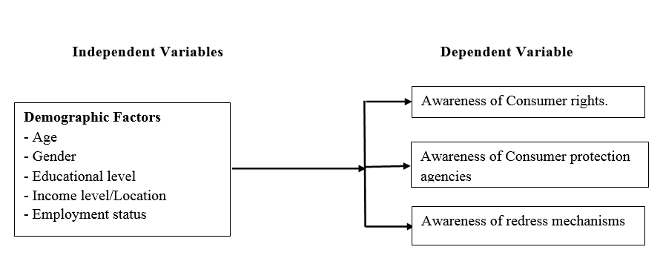
Figure 2.11-1: Conceptual Framework
(Source: Researcher, 2019)

CHAPTER THREE

RESEARCH METHODOLOGY

Introduction
This chapter discusses the research study design, sampling method, study area, target population, sample size, data collection tool, data collection procedure, data analysis and presentation, validity and reliability and ethical considerations.

Research Design
In order to achieve the best results from this research, qualitative and quantitative descriptive research approach was adopted. Descriptive research provides a complete and accurate picture of the situation, whereas quantitative data can be used to describe the situation in terms of frequencies, central tendencies and dispersion (Struwig & Stead, 2001). Qualitative analysis helped to get in-depth information from respondents as well as obtain their views on improvement initiatives. The advantages of these approaches are that it saves time and money, gets accurate results, ensures confidentiality for individual respondents and does not require very large samples (Rourke & Anderson, 2004).

Population and Target Sample
Nairobi County was purposively chosen since the city has the highest population of 3.2 million people. Further to this, half of this population resides in informal settlements where incidence of low income is prevalent (Mutisya & Yarime, 2011).
Target Population: A simple random sampling technique was used to choose the administrative divisions for the study. The divisions selected for the study were; Hurlingham, Westlands, Lower Kabete, Muthaiga and parts of Langata representing the upper income consumers, Roysambu, Kahawa, Harambee, Donholm and Embakasi representing the middle-income consumers and Huruma, Kibera and Viwandani representing the low-income consumers. Upper income earners make over Ksh120, 000 a month and account for 3.7% of the population while middle-income earners make between Kshs. 23,000 and Kshs 119,999 per month and account for 24% of the population while lower income earners make less than Kshs 23,271 per month and make up 72% of the population (Central Bureau of Statistics, 2009).

The total population of Langata constituency is 176,314, Kiambu 201,986, Westlands 176,689, Embakasi North 181,388, Embakasi East 163,858, Makadara 160,434, Starehe is 166,000 and Kasarani 200,984. The total population of the target area is 1,787,343 (Central Bureau of Statistics, 2009).

Sampling method
Stratified random sampling technique was used to select consumers who participated in the study. The consumers in each stratum were selected using stratified random sampling, a non-probability approach based on income to ensure one relatively ‘low’, ‘middle’ and relatively ‘high’ is selected. This approach was recommended by Patton (1990) as it illustrates characteristics of sub-groups of interest and facilitates comparison between the different groups. Consumers were stratified into upper income earners, middle-income earners and lower income earners to constitute three sub-groups after which each stratum was sampled as an independent sub-population out of which individual elements were selected randomly. This method was selected because the sub-groups are homogenous. The strata should be mutually exclusive and every element in the population must be assigned to one stratum.

Simple random sampling was then used to select respondents (consumers) from each household. This approach gave every consumer in the sub-regions an equal and independent chance of being selected. Sampling was without replacement and each element was sampled only once.

Sample Size
The sample size was determined using proportional sampling method which produced a total of 384 based on Equation 1.
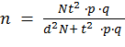………………………… Equation 1
Where
N = 1,787,343 is the total population of the target area
t = z number, is the confidence interval (for 95 % confidence interval t = 1.96)
p = probability of an event occurring (i.e. proportion of consumers who are aware of consumer rights, consumer protection agencies and redress mechanisms was approximated to be 50%)
q = probability of an event not occurring (i.e. proportion of consumers who are not aware of consumer rights & protection agencies)
d = acceptable error rate during sampling (approximated to be 0.05)

Table 3.5-1: Sample size distribution
High Income |  | Middle Income |  | Low Income
 | N |  | N |  | N
Hurlingham | 25 | Roysambu | 25 | Kawangware | 25
Westlands | 26 | Kahawa | 26 | Kariokor | 26
Lower Kabete | 26 | Harambee | 26 | Huruma | 26
Muthaiga | 25 | Donholm | 25 | Kibera | 26
Langata | 26 | Embakasi (Tasia) | 26 | Viwandani | 25
Total | 128 |  | 128 |  | 128

Data Collection Tools and Procedure
This study used structured questionnaire as the main data collection tool. Questionnaires are the commonly used instruments to collect important information about the population. The questionnaire included both open and closed-ended questions. Before administering the questionnaires, authorization was sought from the relevant office in the Nairobi County government office. The unstructured questions gave the respondents the freedom to respond in one’s own words. The questionnaire in Appendix A is divided into sections which includes an introductory note explaining the objectives of the study as well as time estimate for completion. Section has questions regarding the participant’s background and demographics using closed questions; section two covered questions on consumer awareness and knowledge towards consumer rights and protection in Nairobi and section three covered consumer protection institutions and the final section was on consumer issues and redress mechanisms in FMCG sector. Questionnaires were personally administered to the respondents by the investigator with the help of research assistants. The research assistants were trained on data collection techniques, content of the questionnaire and research objectives.

Data Analysis and Presentation

Data entry and Cleaning
All data on the survey questionnaires were entered by the researcher into Microsoft Office Excel 2013. This was followed by quality checking where each of the entries was proof-read against the original set of data. After cleaning, the proof-read data set was exported onto data editor in SPSS 19. Ninety eight percent (i.e. 379 respondents) response rate was achieved for the study.

Data Coding
The survey instrument consisted of 3 sections: Awareness on consumer rights, Consumer protection organizations and redress mechanisms. The variables were created and coded to facilitate statistical analysis. Non-continuous variables were assigned numbers to reflect the different categories. For instance, consumers with no education were coded as 1, those with primary education as 2, etc.

Statistical Analysis
The study used SPSS version 19 software for analysis. Data processing involved undertaking appropriate statistical tests on the quantitative data. Different statistical tests including: descriptive statistics, inferential statistics and regression analysis were employed. Information was presented in tables and figures for ease of understanding and interpretation.

Analytical model
Nonlinear probability models such as binary logit and probit models are widely used in quantitative sociological research. One of their most common applications is to estimate the effect of a variable of interest on a binary outcome when potentially confounding variables are controlled (Karlson et al, 2012). Logit and probit regression analysis are the multivariate techniques which allow for estimating the probability that an event occurs or not, by predicting a binary dependent outcome from a set of independent variables. The response y_{i} is equal to 0 if default occurs (with probability P_{i}) and to 1 if default does not occur (with probability 1- P_{i}). In regression models we wish to model the probability P_{i} that the default will occur by specifying the following model.

P_{i} = f (α + β’Xi) ……………………………………………………… Equation 2

Where
x_{i} = Demographic variables
α + β = Estimated parameters

In this case, the sign is interpreted and not the coefficients and it depends on the functional form of Φ (x′β). Moreover, probit analysis is based on the cumulative normal probability distribution and the binary dependent variable, y, takes on the values of zero and one (Greene, 2004). The probit analysis provides statistically significant findings of which independent variables X1, X2 and X3 increase or decrease the probability of consumer awareness to their rights and protection.

In the binary probit model, consumer awareness was taken as 1, while no awareness as 0. It was assumed that the ith consumer obtained maximum utility; he or she was aware of his or her rights and protection rather than not being aware of rights and protection. Based on this basic model, the following probit model was developed:

……………………. Equation 3

Where:
Y – The dependent variable took two forms (0 or 1). Consumer awareness to rights, consumer protection agencies, and redress mechanisms were the dependent variable which were dummies with the value of 1 for awareness and a value of 0 for no awareness.
X_{1-n} – Independent variables of the study (age, gender, highest level of education and Income level)
Β_{o} – The regression constant
Β1-n – The regression coefficients by each of the independent variables
Є – The standard error

The probabilities that consumers or respondents were aware of their rights and protection or not was calculated using Pr (Yi=1) = Φ (βXi) and with many explanatory variables, Φ (α+βX₁+ βX₂ +…. β_{k} X_{k)} was the probability that consumers with X₁, X₂…. Xk and in this study certain demographic characteristics were more likely to affect awareness to consumer rights and protection. X₁…. Xk were set to values of interest and then probabilities could be estimated.

This model was estimated using the Maximum Likelihood Estimation (MLE) technique with binary probit discrete choice model to generate the odd ratios and the marginal effects estimates (Liao, 1994; Uzunoz & Akcay, 2012). Probit model has been used in past studies such as (Lago & Lago, 2010; Torgler & Schneider, 2007; Torgler, 2005) and it assumes normal distribution of errors (Uzunoz & Akcay, 2012).

Variables
As per the conceptual framework, Consumer awareness to rights, awareness to consumer protection agencies and awareness to available redress mechanisms are the dependent variable with demographic factors as the independent variables.

Dependable Variables
Y is a matrix of dependable variables as follows: Y1: awareness to consumer rights (As stipulated in Kenya Consumer Protection Act, 2010 article 46). Y2: Awareness to consumer protection organizations/institutions/agencies. Y3: Awareness to available redress mechanisms. This takes the value 1 if a consumer is aware of their rights, consumer protection organizations or available redress mechanisms and 0 if a consumer is not aware.

Independent Variables
X is a matrix of independent variables (demographic characteristics) as follows:

Gender: this is whether the consumer is male or female. The variable male took the value 1 if male and 0 if otherwise. The reference group was female.

Age: the respondents’ age was categorized into two groups: below 40 years and over 40 years. Age 1 took the value 1 if age is < 40 years and 0 if otherwise. The reference group was above 40 years of age.

Education level: where the correspondents’ education was categorized into two groups: Below secondary education and above secondary education. Above secondary education includes secondary school, certificate/diploma, degree/masters and others (Vocational training polytechnic). Edu1 took the value 1 if highest level of education is secondary and above and value 0 if otherwise. The reference group was above secondary education level.

Income level: measured as monthly income. Income level was categorized into two groups: Kshs 0 to 22,999 for low income and above Kshs 23,000 for middle to high income. Income level took the value 1 if low income and 0 if middle to high income. The reference group was high income.

Expected outcome for awareness of consumer rights
The coefficient of age was expected to be positive or negative. It can be negative as reported by Krishnakumar & Sakthiventhan (2012) in the study on consumer protection awareness among Rural Consumers in Cuddalore district in India who observed that, the awareness level of the law of adulteration of food and drug is comparatively high among the young age respondents than other age groups. But, more than 30 years old people were having very low level of awareness towards adulteration of foods and drugs. The coefficient can be positive as reported in Masmi (2012) where the middle-aged citizens (35-55) more frequently report receiving information about consumer rights compared to younger and older consumers.

For education it was expected that there would be a positive relationship between education and consumer rights and protection awareness since the level of awareness is expected to increase as the level of education goes up. Thus, the coefficient of education was expected to be positive in reference to the reference group (no education). This is consistent with the findings of Darden & Babin (1994), Ishak and Zabil (2012), Nair (2012), Rousseau & Venter (1995) and Rousseau & Venter (1996) who found significant difference in the level of awareness to consumer rights across consumers with different levels of education. In this study, higher education refers to tertiary education (i.e. diploma, bachelor and above certificates), while the lower education refers to primary or secondary school's certificates. Awareness level increased with the level of education. This means that knowledgeable and alert consumers are aware of their rights and can protect themselves efficiently.

Regarding income it was expected that there would be a positive relationship between income and consumer awareness of their rights and that the coefficients of income would be positive relative to the reference group. Masson (2007) in a research on consumer protection awareness in South Africa found that there was a strong positive relationship between consumer incomes and awareness on the four basic consumer rights at the 99% confidence level. In other words, the higher the income the respondents earned, the more likely they were to know their basic consumer rights. This could be because high income consumers may be more informed, willing to learn, and pay attention to different types of media (including educational programs), which expose them to this consumer awareness and knowledge. This is supported by Wilson et al. (2009) who observe that low income consumers are not only more likely victims of abuse by lenders, but they are also less aware of consumer protection provisions and their rights to seek recourse.

For gender, it was expected that male consumers will have higher awareness level than females. Thus, the coefficient of male was expected to be positive. This is consistent with the finding of Krishnakumar & Sakthiventhan (2012) in the study on consumer protection awareness among rural consumers in Cuddalore district in India, where they found that male consumers were having comparatively high level of awareness than female and this was linked to the higher literacy level in men compared to women in India.

Expected outcome for awareness to consumer protection agencies
The coefficient of gender, age, income level and level of education was expected to be negative. It can be negative as reported by Donoghue’s (2008) who found no significant relationships between gender, age and level of education and awareness to consumer protection.

Expected outcome for awareness to redress mechanisms
The coefficient of gender, age, income level and level of education were expected to be negative. It can be negative as reported by Donoghue’s (2008) who found no significant relationships between gender, age and level of education on the one hand, and the different types of complaint action (private and public action) on the other. Concerning the relationships between level of income and private and public complaint actions respectively, Donoghue (2008) found no significant relationships between level of income and telling friends, family and/or acquaintances about the bad experience (private action) and contacting the retailer/manufacturer to obtain redress (repairs/a replacement/a refund) (public action) and contacting a repair service other than that supplied by the retailer or manufacturer (public action) respectively.

Validity and Reliability
In order to establish the reliability of the questionnaire, a pilot study was done on a sample of 10 respondents selected using random sampling. This study was carried out in form of test-retest where the questionnaire was administered twice with a brief time lapse between the first and second test. The participants in the pilot test did not participate in the main research. Cronbach's alpha was used to check internal consistency and reliability of the questionnaire based on the feedback of the pilot test.
The results of the study were uploaded in SPSS database and tested using Cronbach alpha. Results of the test yielded a value of 0.58, confirming instrument reliability as shown in table 3.8-1. The higher the score, the higher the reliability of the generated scale. Nunnaly (1978) has indicated 0.7 to be an acceptable reliability coefficient but lower thresholds are sometimes used in literature. An alpha result of 0.5 is acceptable but weak and particularly in a qualitative study.

Table 3.8-2: Reliability statistics of pilot study
Construct | Cronbach Alpha
Awareness of rights | .580

Source: Researcher, 2019

Ethical Considerations
There are several ethical considerations that were considered in the research process. The first consideration was to ensure confidentiality and protection of the anonymity of respondents. All communication with respondents and any information given for the purpose of the study were treated with confidence. All the respondents to the study were coded to protect their anonymity. An explanatory letter was used to assure the respondents of the confidentiality of their responses. Participation in the study was entirely voluntary and the questionnaire contained a clear narrative describing the purpose of the study as well as a guarantee that the information provided will only be used for the purposes stated.
CHAPTER FOUR

RESULTS AND DISCUSSION

Introduction
This chapter presents findings and analyses of results within the framework of the set study objectives. It presents various descriptive statistics showing participant characteristics (age, gender, income level and highest level of education). Results of probit regression analysis have been presented to show significant predictors of awareness on consumer rights, consumer protection agencies and available redress mechanisms.

Response rate
A total of 379 respondents (about 98% response rate) were successfully reached during the interviews stage of the research. This response rate has sufficiently surpassed the minimum threshold sample size of 10 percent as suggested by Gay (2005) and the 30% as considered acceptable by (Kothari, 2004).

Demographic characteristics
The respondents were asked to state their gender, age, highest level of education, employment status and income. Results are shown in Table 4.3-1.
Table 4.3-3: Demographic information
Demographic Information
 |  | Frequency (n) | Percent (%)
Gender | Male | 173 | 45.6
Gender | Female | 206 | 54.4
Gender | Total | 379 | 100
Education Level | Below Secondary education | 164 | 43.4
Education Level | Higher education | 214 | 56.6
Education Level | Total | 378 | 100
Age | Below 40 Years | 265 | 71.4
Age | Above 41 Years | 106 | 28.6
Age | Total | 371 | 100
Employment Level | Employed | 242 | 63.9
Employment Level | Unemployed | 137 | 36.1
Employment Level | Total | 379 | 100
Income Level | Low income level | 184 | 53.2
Income Level | High Income Level | 162 | 46.8
Income Level | Total | 346 | 100

Source: Researcher, 2019
Table 4.3-1 shows the demographic characteristics of the respondents. Majority of respondents 54.4 % (n=206) were female whereas male was 45.6 % (n=173) and this shows that majority of respondents were female. The distribution of respondent’s by education level shows that majority of respondents 56.6 % (n=214) have tertiary education and above and those with secondary education and below were 43.6% (n= 166). Majority of respondents 71.4 % (n=265) were below 40 years of age and 28.6 % (n=106) were above 41years. Regarding employment status, majority of respondents 63.9 % (n=242) were employed and 36.1 % (n=137) were unemployed. Similarly, on the income level, majority of respondents 53.2 % (n=184) were in the low-income level bracket whereas those respondents from medium to high income level categories were minority respondents representing 46.8 % (n=162).

Awareness Level
The level of awareness was measured using binary responses (yes or no) and multiple-choice type questions. The data was statistically analyzed to give percentage level of awareness on consumer rights, consumer protection agencies and awareness on available redress mechanisms. Figure 4-4-1 shows a bar graph of the percentage of consumers who are aware of consumer protection rights, consumer protection agencies and redress mechanism.
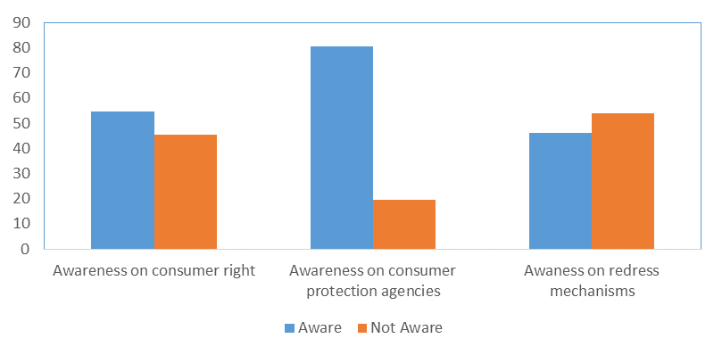 Figure 4.4-2: Levels of consumer awareness on rights and protection
Percent (%)

Level of awareness to consumer rights
From the graph, it appears that 54.5% of respondents are aware of their rights while 45.5% are not aware. According to research by Surekha (2010), consumer’s awareness about rights and grievance redressal in India, was reported as 66% of the consumers. Masmi (2012), in their survey of consumer protection and awareness in Serbia found that 60% of citizen’s are aware of consumer rights.
Consumers in most of the EU Member States show an overall awareness of the existence of consumer rights, protection and redress mechanisms, with varying degrees of knowledge. The degree of awareness of consumer rights and protection measures varies from ‘high’ in Member States such as Sweden, Denmark, Netherlands, Belgium, The united Kingdom and Germany; to ‘medium’ in Members States such as Cyprus, Greece, Italy, Austria and Poland, to ‘low’ in Estonia, Romania, Bulgaria and Lithuania and most of the Eastern European states (ARC Rynek, 2009).

The level of consumer awareness to their rights in Nairobi, Kenya is lower than in India, Serbia and some EU member states. This supports the null hypothesis that awareness to consumer rights is lower in developing countries.

Figure 4-4-2 shows a bar graph of the percentage of the frequently mentioned consumer rights.

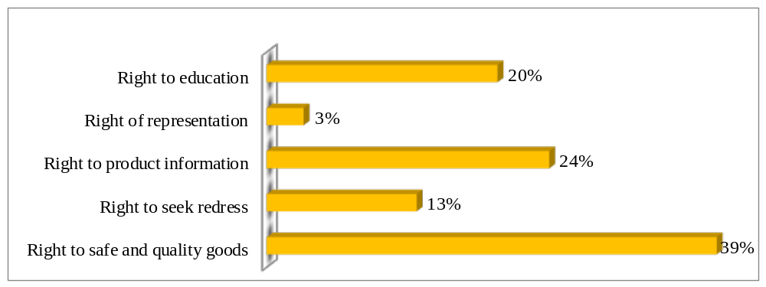
Figure 4.4-3: Most frequently mentioned consumer rights
From the figure, the proportion of consumers who are aware of the right to safe and quality goods is almost 40%. The next most common rights are the right to product information (24%), right to education (20%), right to seek redress (13%) and the right to representation is 3%. This shows that majority of consumers are not aware of the right to seek redress and the right to representation.
Figure 4.4-3 shows a bar graph of the sources of information on consumer rights.
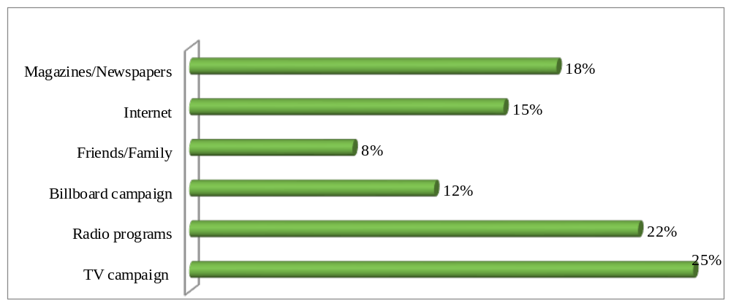
Figure 4.4-4: Sources of information on consumer rights
From the graph it appears that TV is commonly mentioned as a source of information about consumer rights by 25% of the respondents. It’s followed closely by radio programs at 22%, magazines and newspapers at 18% and internet at 15%. Friends and family are also mentioned as a source of information, yet significantly less frequently (8%).

Level of awareness to consumer protection agencies
Consumer protection agencies stop unfair, deceptive and fraudulent business practices by collecting complaints and conducting investigations, suing companies and people that break the law, developing rules to maintain a fair marketplace, and educating consumers and businesses about their rights and protection. In this research we sought to find out if consumers are aware of institutions/Organizations that have the mandate to protect them and the responses are as below.
On awareness to consumer protection agencies 80.5% are aware of the consumer protection agencies compared to 19.5% who are not aware of the consumer protection agencies. Nkamnebe et al. (2009) in the research on consumer protection awareness in Nigeria found that 14% of the
surveyed sample claimed that they are aware of consumer associations in Nigeria. Majority of the respondents, 62 or 67%, claimed that they are familiar with one or two of the laws and institutions. 21 or 23% of the respondents indicated familiarity with four laws and institutions whereas 7 or 7% said they are familiar with six. Out of the 93 respondents, only three or 3% indicated that they are familiar with all the Decrees and Boards.

Surekha (2010), in his survey on consumer’s awareness about rights and grievance redressal in India, reported that 82% of consumers are aware of the Consumer Protection Agencies.

The level of awareness of consumer protection agencies in Kenya is higher than in Nigeria but lower than in India. This data supports the alternative hypothesis that the level of awareness to consumer protection agencies is higher in developing countries.

Figure 4.4-4 shows a bar graph of percentage of consumers who know certain consumer protection agencies.

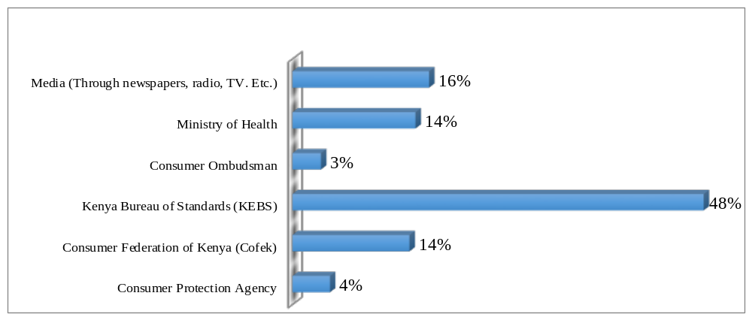
Figure 4.4-5: Institutions/organizations dealing with consumer rights protection

From the graph, almost half of the respondents (48%) know Kenya Bureau of Standards (KEBS) as a consumer protection agency. The level of awareness on other consumer protection agencies like Consumer federation of Kenya (COFEK), the media, Ministry of Health, Consumer Ombudsman and Consumer Protection Agency is very low (16%). While market inspections are spontaneously mentioned by half of the respondents, consumer protection organizations are mentioned less often by the citizens.
The researcher went further to find out if the consumers who are aware of these agencies/ institutions trust these agencies/ institutions. A Likert scale was used to rate the extent at which they trusted the agencies/Institutions and the output is shown in figure 4.4-5.

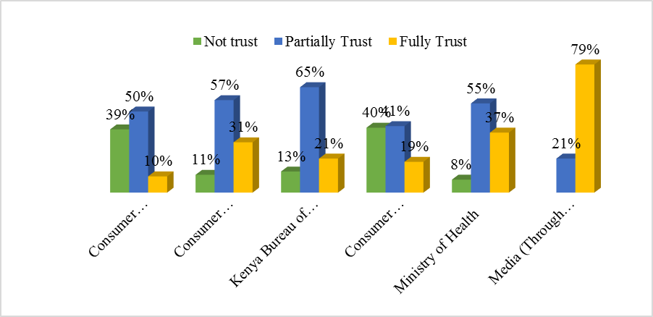

Figure 4.4-6: Level of satisfaction with the Consumer protection agency

From that graph, it appears that 79% of the consumers in Nairobi County trust the media regarding protecting consumers. Fifty-five partially trust the Ministry of Health, while 41% partially trust the office of the ombudsman, sixty five percent partially trust the Kenya Bureau of standards (KEBS), fifty seven percent partially trust the consumer federation of Kenya (COFEK) and 50% partially trust the Consumer protection agency. The level of trust for most of the consumer protection agencies is very low.

Level of awareness to available redress mechanisms
Regarding awareness to available redress mechanisms, 54% are aware of the available redress mechanisms while 46% who indicated they are not. Research done by Nkamnebe et al. (2009) in the research on consumer protection awareness in Nigeria found that consumers are conscious of their rights in exchange relationship as they were asked to indicate their action whenever they discover a purchased product to be fake, substandard or adulterated. 55% of the respondents would stop buying the brand of product, 32% said that they will take it as their luck, and 13% said that they would fight for their rights through legal processes. Further, 76% of the respondents have never taken any report of fake, sub-standard or adulterated product to such agency like SON or NAFDAC. Only 24% said that they have taken legal action or reported to consumer protection agencies.

Across all Member States in the EU there is far less knowledge of the specifics of the various redress mechanisms available; the processes involved, where to find information and who to ask for help. Even ‘experienced’ consumers know only about the mechanism they have used and not about the range of available options discussed in the interview). The UK is a notable exception in this regard with consumers feeling well informed about what to do if they feel a supplier’s response to a complaint is unsatisfactory. Many consumers know that the courts offer a possible route but, beyond this, knowledge is very patchy. ‘Experienced’ consumers clearly had more knowledge about redress mechanisms than ‘inexperienced’ consumers. However, their knowledge tended to be limited to the specific mechanism they had used and did not extend to the alternatives available (ARC Rynek, 2009).

Compared to Nigeria, the level of awareness to available redress mechanisms is higher in Kenya. There seems to be a low level of awareness to available redress mechanisms in the EU member states. The results support the alternative hypothesis which indicates that the level of awareness to redress mechanisms is higher in developing countries.

Figure 4.4-6 shows the percentage level of consumer dissatisfaction with a product purchase.
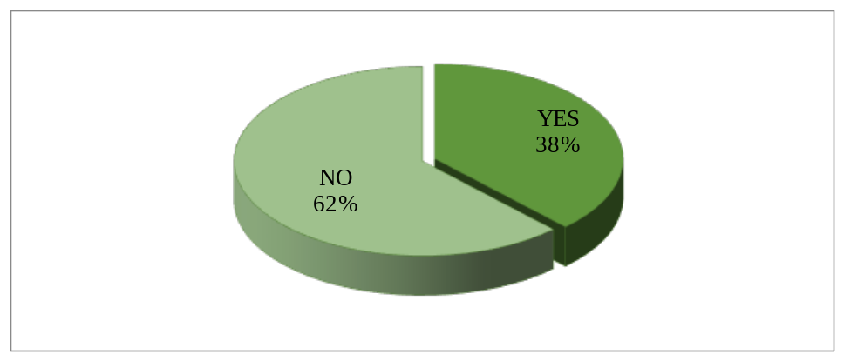
Figure 4.4-7: Level of consumer dissatisfaction
The graph shows that majority of the respondents (62%) have not encountered an issue in with a product that they purchased in the Kiosk, retail shop or supermarket in the recent past. A smaller proportion of the consumers have recently experienced an issue.
Figure 4.4-7 shows a graph of percentage level of dissatisfaction per product category.
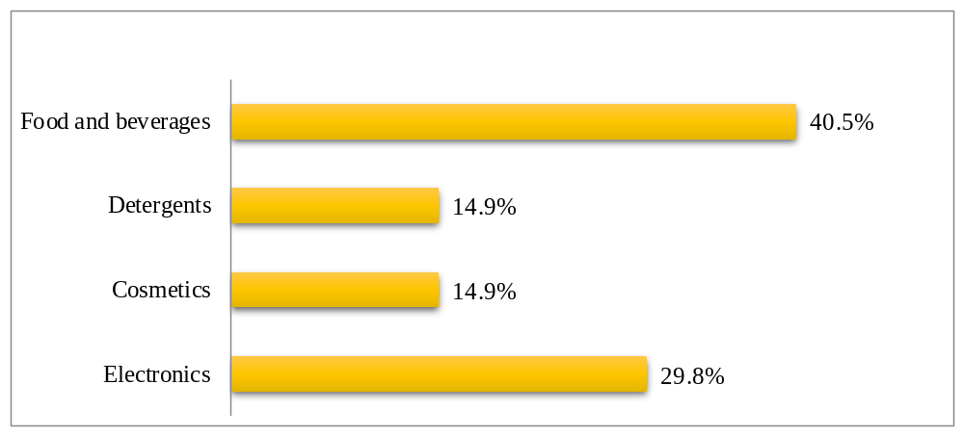
Figure 4.4-8: Dissatisfaction per product category

From the graph, it appears that the highest level of dissatisfaction was reported in Food and beverages at 40.5%. Electronic appliances followed with almost 30% issues and detergents and cosmetics were below 15%.

Figure 4.4-8 shows the type of problems encountered by consumers when they purchase FMCG products.
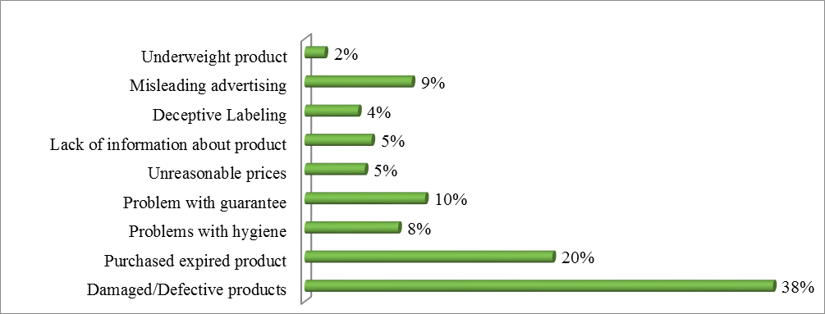Figure 4.4-9: Types of problems experienced after purchasing FMCG products
It appears that damaged or defective products is experience mentioned by 38% of the consumers. Purchase of expired products is mentioned by about 20% of respondents. The other issues such as underweight products, misleading advertisements, deceptive labelling, unreasonable pricing and hygiene constitute less than 10% of the issues.
Figure 4-9 shows the actions that consumers take when they are dissatisfied with a purchase
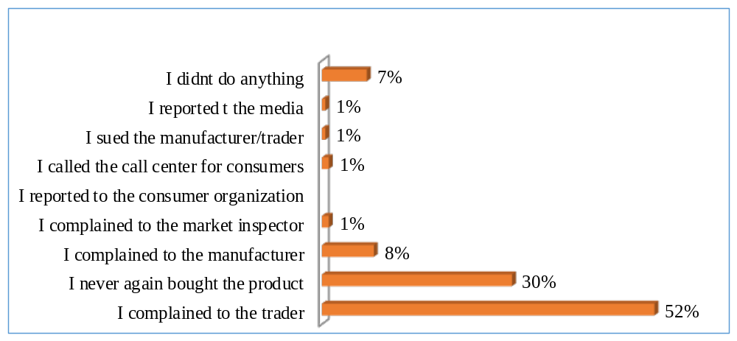
Figure 4-10: Action taken after dissatisfaction
A larger proportion of the consumers (52%) complained to the trader with 30% not buying the product again and 8% complaining to the manufacturer directly. The other responses on what they did was negligible as seen above.

Figure 4.4-10 shows the level of consumer satisfaction after complaining to a trader, producer or service provider.

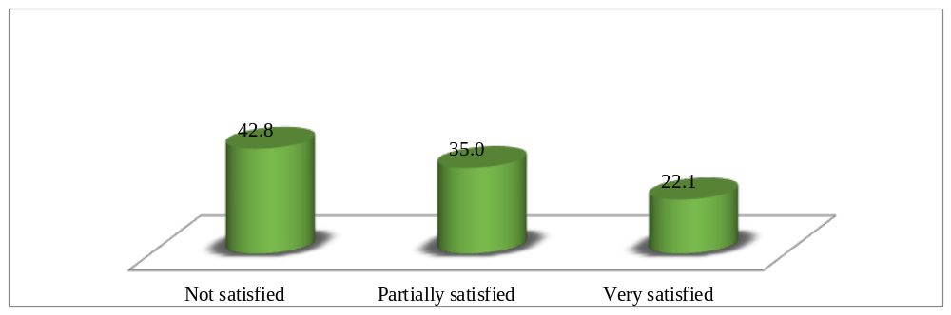
Figure 4.4-11: Level consumer satisfaction with complaints to traders

Only 22% of the consumers were with how the complaint was addressed. On the other hand, 42.8% were not satisfied and 35% were partially unsatisfied.
Consumer protection can be meaningful only if there are provisions for consumers to seek redress for perceived wrongs and to prevent future abuses. This may mean achieving redress through specific remedies in law such as refund of money, repair/return/replacement of goods, compensation for loss or damage, cancellation of contracts, use of legal structure to pursue and enforce consumer claims such as small claims courts, tribunals, civil courts, consumer claims departments or settlement avenues for consumer claims such as consumer affairs department, mediation channels or enforcement departments.

Relationship between awareness level and demographic characteristics

Gender and level of awareness
Figure 4.5-1 shows the graphical relationship between gender and the level of awareness to consumer rights, consumer protection agencies and redress mechanisms.
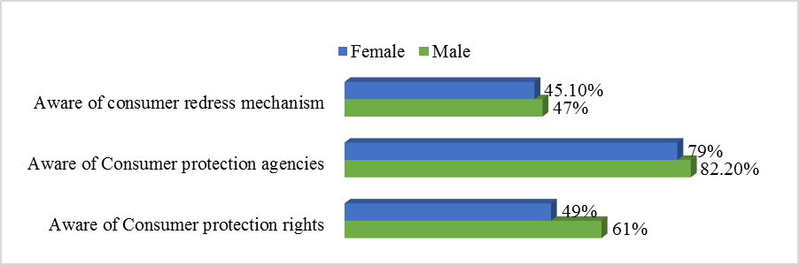
Figure 4.5-12: Relationship between awareness level and gender
From the figure, it appears that the proportion of those who are aware of consumer protection rights is 60% for male and 50% for female; those who are aware of consumer protection agencies is 81% for male and 79% for female; while those who are aware of consumer redress mechanism stands at 45% for male and 43% for female. The finding that males have a higher awareness level than female consumers is consistent with our hypothesis that males tend to be aware of consumer issues than females because of the higher literacy level in men compared to women. This is consistent with the findings of Krishnakuma and Sakthiventhan (2012).

Table 4.5-1 shows results of the difference of means between male and female gender.
Table 4.5-4: Results of difference of means (gender)
 |  | Awareness of consumer rights | Awareness of consumer protection agencies | Awareness to redress mechanism
Gender | Female | 1.39 | 1.21 | 1.55
Gender | Male | 1.51 | 1.18 | 1.53
Gender | Difference | .120 | .032 | .019
Gender | T-statistic | 2.347 | .781 | .370
Gender | P-value | .019** | .435 | .712
p < 0.01***, p < 0.05**, p < 0.1*

(Source: Researcher, 2019)
From the table, the t-test is statistically significant (p=0.019, t=2.347) at conventional levels for consumer rights and not significant for awareness to consumer protection agencies and redress mechanisms. The finding show that male consumers have a higher awareness level to consumer rights than female consumers and these results support hypothesis 2. Male consumers may be more aware of their rights than female consumers because of the higher literacy level in men compared to women.

Income and level of awareness
Figure 4.5-2 shows the relationship between awareness level and income level
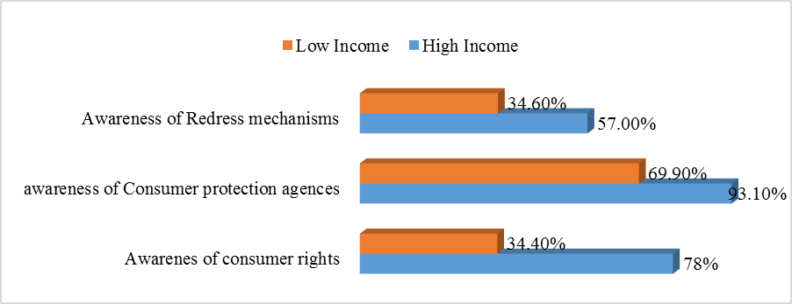
Figure 4.5-13: Relationship between awareness level and income level
From the graph, it is evident that awareness to consumer rights is highest (78%) among the high-income consumers and low (34.4%) among the low-income consumers. Awareness to consumer protection agencies is higher (93.1%) among the high-income consumers and 69.9% among the low-income consumers. Awareness to redress mechanisms is 57% among the high-income consumers and 34.6% for the low-income consumers. There seems to be higher awareness to consumer rights, consumer protection organization and redress mechanisms among the high-income consumers and this could be attributed to the fact that higher income consumers have better access to information than the low-income consumers. This is consistent with the findings of Masson (2007) in a research on consumer protection awareness in South Africa which shows that there was a strong positive relationship between consumer incomes and awareness on the four basic consumer rights at the 99% confidence level.

Table 4.5-2 shows results of the difference of means between low- and high-income consumers.
Table 4.5-5: Results of difference of means (Income level)
 |  | Awareness of consumer rights | Awareness of consumer protection agencies | Awareness to redress mechanism
Income level | Low | 1.59 | 1.26 | 1.63
Income level | High | 1.19 | 1.06 | 1.40
Income level | Difference | .395 | .204 | .232
Income level | T-statistic | 7.567 | 4.676 | 4.192
Income level | P-value | .000*** | .000*** | .000***
p < 0.01***, p < 0.05**, p < 0.1*

(Source: Researcher, 2019)
From the t-test, the difference is statistically significant (p=0.000, t=7.567, 4.676, 4.192) at conventional levels for consumer rights, awareness to consumer protection agencies and redress mechanisms. The results support the alternative hypothesis that demographic characteristics (Income level) affects the level of awareness to consumer rights, consumer protection agencies and redress mechanisms.

Highest level of education and level of awareness
Figure 4.5-3 shows the relationship between awareness level and highest level of education.
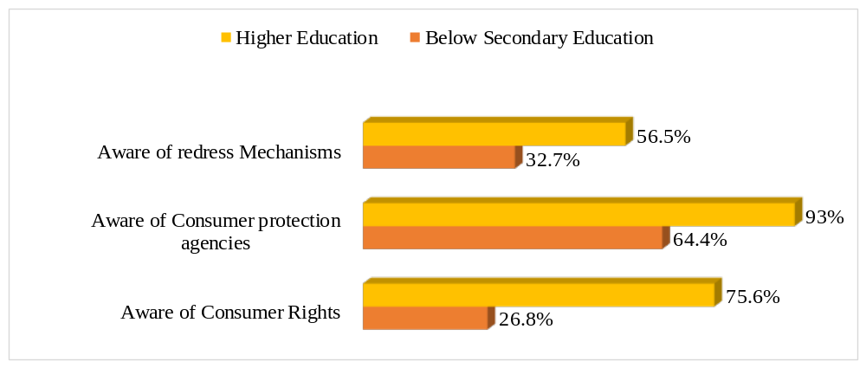
Figure 4.5-14: Relationship between awareness level and education level
The graph above shows that consumer with higher education have more awareness to consumer rights, consumer protection agencies and redress mechanisms. This is consistent with the findings of Darden & Babin (1994). The results show that knowledgeable and alert consumers are aware of their rights and can protect themselves efficiently.

Table 4.5-3 shows results of the difference of means between higher educated and consumers with below secondary education.
Table 4.5-6: Results of difference of means (Education level)
 |  | Awareness of consumer rights | Awareness of consumer protection agencies | Awareness to redress mechanism
Education level | Below Secondary | 1.73 | 1.36 | 1.67
Education level | Higher education | 1.24 | 1.07 | 1.44
Education level | Difference | .488 | .284 | .237
Education level | T-statistic | 10.748 | 7.327 | 4.670
Education level | P-value | .000*** | .000*** | .000***
p < 0.01***, p < 0.05**, p < 0.1*

(Source: Researcher, 2019)
From the t-test, the difference is statistically significant (p=0.000, t=10.748, 7.327 and 4.670) at conventional levels for consumer rights, awareness to consumer protection agencies and redress mechanisms. The results support the alternative hypothesis that demographic characteristics (Education level) affects the level of awareness to consumer rights, consumer protection agencies and redress mechanisms.

Age and level of awareness
Figure 4.5-4 shows the relationship between awareness level and age.
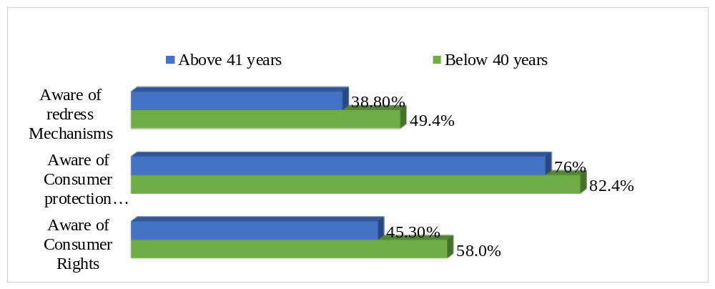
Figure 4.5-15: Relationship between awareness level and age

From the graph above, it appears that younger consumers have higher awareness level than older consumers and this could be because the younger consumers have access to information through internet and other sources.

Table 4.5-3 shows results of the difference of means between consumer of above 40 and those below 40.
Table 4.5-7: Results of difference of means (Age)
 |  | Awareness of consumer rights | Awareness of consumer protection agencies | Awareness to redress mechanism
Age | Below 40 | 1.42 | 1.18 | 1.51
Age | Above 41 | 1.55 | 1.24 | 1.61
Age | Difference | .127 | .065 | .106
Age | T-statistic | 2.221 | 1.414 | 1.828
Age | P-value | .027** | .158 | .068*
p < 0.01***, p < 0.05**, p < 0.1*

(Source: Researcher, 2019)
From the t-test, the difference is statistically significant (p=0.027, t=2.221) at conventional levels for impact of age on level of awareness to consumer rights and awareness to redress mechanisms. The results are consistent to the hypothesis 2. The t-test is not statistically significant at 0.1% significant level (p=0.158, t=1.414) for awareness to consumer protection agencies. The results support hypothesis 1.

Probit regression Results
Probit regression analysis is done in order to predict the impact of independent variables on the dependent variables.

Impact of demographic factors on level of awareness to consumer rights
Table 4.6.1 shows results of probit regression between level of awareness to consumer rights and demographic factors.
Table 4.6-8: Probit regression results for effect of demographic factors on level of awareness to consumer rights.
Parameter Estimates
 |  |  |  |  | Estimate |  | Std. Error | df | Sig.
Aware of consumer rights |  |  |  |  | 0.328 |  | 0.269 | 1 | 0.223
Gender |  | Male |  |  | 0.256 |  | 0.154 | 1 | .097*
Age |  | Below 40 Years |  |  | -0.355 |  | 0.176 | 1 | .044*
Education |  | Below Secondary |  |  | 1.163 |  | 0.181 | 1 | .000***
Income |  | Low |  |  | 0.369 |  | 0.209 | 1 | .077*
Model | -2Log Likelihood |  | Pseudo R-Square | Observation
 | 339.914 |  | 0.477 | 341
Link function: Probit.
p < 0.01***, p < 0.05**, p < 0.1*

Results on the table show that gender, education and income positively affect awareness to consumer rights while age negatively affect awareness to consumer rights. However, gender, education and income significantly affect awareness to consumer rights (p=0.097, 0.000 and 0.077 respectively). These results are consistent with the findings of Krishnakuma and Sakthiventhan (2012), Masson (2007) and Darden & Babin (1994). The results support the null hypothesis that demographic factor (gender, education and income) affect the level of awareness to consumer rights.
Although age negatively affected the level of awareness to consumer rights, it significantly affected awareness to consumer rights (p=0.044). It means that increasing age was associated with a decreased probability of awareness of the consumer rights by the consumers in Nairobi County. This is inconsistent with Masmi (2012) who showed that middle-aged citizens (35-55) more frequently report receiving information about consumer rights compared to younger and older ones (66% vs. 54% respectively). The results support hypothesis 2 and the results can be attributed to access to social media by the younger consumers.

The Pseudo R² is 0.477 and can be interpret as 47.7% of the variability in the model is explained by the independent variables (demographic factors).

In Summary, among the demographic factors, gender, education and income of the consumer significantly contribute in enhancing the extent of awareness to consumer rights among FMCG consumers and thus, the hypothesis of insignificant effect of demographic factors on level of awareness to consumer rights has been rejected.

Probit analysis of impact of demographic factors on level of awareness to consumer protection agencies
Table 4.6.2 shows results of probit regression between level of awareness to consumer protection agencies and demographic factors
Table 4.6-9: Probit regression results for effects of demographic factors on awareness to consumer protection agencies
Parameter Estimates
 |  |  |  |  | Estimate |  | Std. Error | df | Sig.
Aware of consumer protection institution |  |  |  |  | 1.768 |  | 0.329 | 1 | 0
Gender |  | Male |  |  | 0.019 |  | 0.174 | 1 | 0.915
Age |  | Below 40 Years |  |  | -0.029 |  | 0.189 | 1 | 0.88
Education |  | Below Secondary |  |  | 1.111 |  | 0.225 | 1 | .000***
Income |  | Low |  |  | 0.314 |  | 0.271 | 1 | 0.247
Model | -2Log Likelihood |  | Pseudo R-Square | Observation
 | 233.62 |  | 0.354 | 338
Link function: Probit.
p < 0.01***, p < 0.05**, p < 0.1*

Results on the table show that gender, education and income positively affect awareness to consumer protection agencies while age negatively affects the level of awareness to consumer protection agencies.
Though the coefficient of gender, education and income are positive, only education significantly affects awareness to consumer protection agencies (p = 0.000). The results support the null hypothesis that demographic factor (Education) affect the level of awareness to consumer rights.
The other demographic variables (Age, gender and income level) do not significantly affect the level of awareness to consumer protection agencies. This is consistent with the null hypothesis. The Summary is that among demographic factors, education level of the consumers significantly contributes in enhancing the extent of awareness regarding consumer protection agencies.
The Pseudo R² is 0.354 indicates that only 35.4% of the variability in the model is explained by the independent variables (demographic factors).

Probit analysis of impact of demographic factors on level of awareness to available redress mechanisms
Table 4.6.3 shows results of probit regression results for effects of demographic factors on the level of awareness to consumer protection agencies.
Table 4.6-10: Probit regression results of effect of demographic factors on awareness to redress mechanisms
Parameter Estimates
 |  |  |  | Estimate |  | Std. Error | df |  | Sig.
Aware of available redress mechanisms |  |  |  | 0.024 |  | 0.251 | 1 |  | 0.925
Gender | Male |  |  | 0.106 |  | 0.142 | 1 |  | 0.456
Age | Below 40 Years |  |  | -0.264 |  | 0.164 | 1 |  | 0.106
Education | Below Secondary |  |  | 0.374 |  | 0.175 | 1 |  | .033*
Income | Low |  |  | 0.39 |  | 0.196 | 1 |  | .047*
Model |  | -2Log Likelihood | Pseudo R-Square |  | Observation
 |  | 290.473 | 0.202 |  | 336
Link function: Probit.
p < 0.01***, p < 0.05**, p < 0.1*

Results on the table show that gender, education and income positively affect awareness to available redress mechanisms while age negatively affects the level of awareness to consumer protection agencies.
Although gender, education and income positively affect the level of awareness to redress mechanisms, only education and income significantly affects awareness to redress mechanisms (p = 0.033 and 0.047) at conventional level. The results support hypothesis 2 that demographic factor (education and income) affect the level of awareness to available redress mechanisms.
The other demographic variables (age and gender) do not significantly affect the level of awareness to available redress mechanisms. This is consistent with the null hypothesis and supports the findings of Donoghue’s (2008) whose findings showed that there are no significant relationships between gender, age, income level, occupation and level of education on the one hand, and the level of awareness on consumer rights and protection.

Among demographic factors, education level and income of the consumers significantly contribute in enhancing the extent of awareness to available redress mechanisms.

The Pseudo R² is 0.202 indicates that only 20.2% of the variability in the model is explained by the independent variables (demographic factors).

CHAPTER FIVE

CONCLUSIONs AND RECOMMENDATIONS

Introduction
This chapter describes key study findings derived from the analyses and discussions on the interaction between demographic characteristics and the level of awareness to consumer rights, consumer protection organizations and available redress mechanisms in Nairobi, Kenya. The chapter concludes by drawing some recommendations and suggestions for further research.

Conclusion
The study objective was to analyze the extent of awareness regarding consumer rights, consumer protection organizations and redress mechanisms among the fast-moving consumer goods consumer. The data of 379 customers have been utilized to identify the level of awareness and factors affecting extent of awareness among the target sample. This study found out that the level of awareness on consumer rights is 54.5% while awareness on consumer protection agencies is 80.5% and 46% for awareness on available redress mechanisms. The level of awareness to consumer rights in Nairobi is low compared to awareness in some developed countries. The level of awareness to available redress mechanisms and consumer protection agencies is not lower than those of developed countries. The most common right that the consumers in Nairobi County are aware of is the right to safe and quality goods. Majority of consumers are not aware of the other rights like the rights to seek redress, rights of representation and the rights to education.

The demographic factors that positively affect the level of awareness to consumer rights are gender, education and income. While the education level of the consumers significantly contributes in enhancing the extent of awareness regarding consumer protection agencies and finally, education level and income of the consumers significantly contribute in enhancing the extent of awareness to available redress mechanisms.

On consumer protection agencies, the Kenya Bureau of Standards (KEBS) is well known by consumers to protect them from unscrupulous traders. Food and beverages are the most prominent product categories when it comes to consumer rights violation. Regarding fast moving consumer goods sector Nairobi county consumers with most products being damaged or defective where most of the consumers reacted by complaining to the trader with others resolving not to buy the product again but despite of these complaints, apparently nothing was done. Media (TV, radio, internet, magazine) was the most common source for the awareness of the consumer rights and protection agencies regarding fast moving consumer goods sector in Nairobi County.
It is noted that in Nairobi, regarding fast moving consumer goods, the common options for consumers to seek redress basically include the following: suggestion boxes, consumer care lines, direct complaints to traders or manufacturers, social media (17%) or to consumer organizations such as Kenya Bureau of Standards (KEBS), or police.

Recommendations
Thus, the analysis reveals that relevant government authorities and institutions need to improve the level of awareness regarding consumer rights, consumer protection agencies and available redress mechanisms among their customers. Regardless of the present efforts of the consumer protection agencies, the level of awareness to consumer rights among the customers of FMCG is relatively lower than those of developed countries.

First, there is need for more focused consumer awareness training to bolster the level of awareness on rights and protection of consumers. The association of awareness on consumer rights and protection with tertiary education and above and household income suggests that less educated consumers or those in low income household are at risk of their rights being violated by unscrupulous traders.

Second, the national government, voluntary organization, media and other institutions should come forward to educate consumers on importance of understanding their rights and protection. This can be done through targeted awareness campaigns on TV, radio and newspapers since these have been found to be the vital media platforms for communicating to consumers in Nairobi. The awareness trainings should focus on consumers of different age groups, income levels and education levels since these factors have been found to influence the level of awareness to consumer rights and protection in Nairobi.

Third, retailers and manufacturers should endeavor to change consumers’ negative perceptions that ‘complaining is not worth the time and effort’ by providing consumers with the means to complain. Alternative redress mechanisms including individual or collective court action against the supplier should be enhanced by the consumer protection agencies to increase the options of redress mechanisms available for consumers.

Suggestions for Further Research
Based on the findings, the study recommends areas for further research. Other factors that may affect the level of awareness to consumer rights, awareness to consumer protection agencies and redress mechanisms such as behaviour and culture were not looked at in this study and hence future research can look at this factor. The present study was based on Nairobi consumers who are majorly urban dwellers and hence results are not generalized to a larger population since there might be difference in social and behavioural aspects between rural and urban dwellers and hence future research should replicate the study to a rural area.

REFERENCES

Adlina, B., & Julie, M. (1995). Consumer Complaint Behaviour: The Case of Electrical Goods. International Journal of Retail and Distribution Management, 23(9), 8-18.
ARC Rynek, (2009). Awareness of consumer rights and analysis of barriers. Journal of Laws 2007, 978(83), 43-47.
Ardic, O. P., Ibrahim, J., & Mylenko, N. (2011). Consumer protection laws and regulations in deposit and loan services: A cross-country analysis with a new data set. World Bank Policy Research Working Paper Series, 2011.
Azrina, A., Hock, H. K., Muhammad, R. R., & Sakina. (2011). Quality and labeling of minerals in selected bottled mineral water. In International Conference on Consumer Law.
Black, H. C. (2009). Black’s Law Dictionary, edited by Bryan A. Garner.(9thed.) US: Thomson Reuters, 9th ed. 2009Ibn Hazm, cAli bin Ahmad.(nd) al-Muhalla bi al-Athar, Beirut: Dar al-Fikr.
Celen, A., Erdogan, T., & Erdogan, T. (2005). Fast Moving Consumer Goods: Competitive Conditions and Policies (No. 0503). ERC-Economic Research Center, Middle East Technical University.
Central Bureau of Statistics. (2009). Population and housing Census Vol 1. Population distribution by administrative areas and urban centers. Nairobi, Kenya.
Chaudhry, K., Chandhiok, T., & Dewan, P. (2011). Consumer Protection and Consumerism in India. International Journal of Multidisciplinary Research, ., 1(1), 2231-5780.
Choi, J., & Chung, W. (2013). Analysis of the Interactive Relationship between Apology and Product Involvement in Crisis Communication: An Experimental Study on the Toyota Recall Crisis. Journal of Business and Technical Communications, 27(1), 4-10.
Cole, C. A., & Balasubramanian, S. K. (1993). Age differences in consumers' search for information: Public policy implications. Journal of Consumer Research, 20(2), 157-169.
Cole, C. A., & Gaeth, G. J. (1990). Cognitive and age related differnces in the ability to use nutritional information in a complex environment. Journal of Marketing Research, 27(1), 175-184.
Darden, W. R., & Babin, B. J. (1994). Exploring the concept of affective quality: expanding the concept of retail personality. Journal of Business research, 29(2), 101-109.
Di Castri, S., Flaming, M., Owino, A, A., & McKee, K. (2011). Consumer Protection Diagnostic Study: Financial Consumer Protection in Kenya. Available at SSRN 1843279.
Donoghue, S. (2008). An explanation of consumer complaint behaviour concerning performance failure of major electrical household appliances. SA: PhD Thesis. University of Pretoria.
Donoghue, S., & De Klerk, H. M. (2009). The right to be heard and to be understood: a conceptual framework for consumer protection in emerging economies. International Journal of Consumer Studies, 33(4), 456-467.
Donoghue, S., & De Klerk, H. M. (2009). The right to be heard and to be understood: a conceptual framework for consumer protection in emerging economies. International Journal of Consumer Studies, 33(4), 456-467.
Gliner, J. A., Morgan, G. A., Harmon, R. J., & Har. (2000). Introduction to inferential statistics and hypothesis testing. Journal of the American Academy of Child & Adolescent Psychiatry, 39(12), 1568-1570.
Greene, W. (2004). Convenient estimators for the panel probit model: Further results. Empirical Economics, 29(1), 21-47.
Hansen, T., Wilke, R., & Zaichkowsky, J. (2010). Managing consumer complaints: differences and similarities among heterogeneous retailers. International Journal of Retail & Distributi, 38(1), 6-23.
HarneyAdvocates, C. C. (2012). New dawn for consumer protection in Kenya - How does it affect you. . Nairobi, Kenya. Retrieved August 20th 2014, from http://www.coulsonharney.com
Consumer International (2015). The global voice of consumers. Retrieved July 14th, 2015, from www.consumersinternational.org
Ishak, S., & Zabil, N. F. (2012). Impact of consumer awareness and knowledge to consumer effective behavior. Asian Social Science, 8(13), 108.
Kenya Ministry of Finance and Economic planning. (2009). Kenya Population census 2009. Nairobi. Kenya.
Karlson, K. B., Holm, A., & Breen, R. (2012). Comparing regression coefficients between same-sample nested models using logit and probit a new method. Sociological Methodology,, 42(1), 286-313.
Khan, M. A. (2013). Consumer rights awareness in urban and rural areas of Muzaffarnagar and Saharanpur districts: an empirical study. (A. M. University, Ed.) Retrieved September 20th, 2014, from Inflibnet: http://hdl.handle.net/10603/13130
Kothari, C. R. (2004). Research methodology. New Age International.
Kothari, C. R. (2008). Research Methodology. New Delhi: New Age international Pvt. Limited.
Lago-Peñas, I., & Lago-Peñas, S. (2010). The determinants of tax morale in comparative perspective: Evidence from European countries. European Journal of Political Economy, 26(4), 441-453. European Journal of Political Economy, 26(4), 441-453.
Lee, C., & Green, R. T. (1991). Cross-cultural examination of the Fishbein behavioral intentions model. Journal of international business studies, 61(3), 289-305.
Liao, T. F. (1994). Interpreting probability models: Logit, probit, and other generalized linear models (No. 101). Sage .
Loomba, A. P. (1998). Evolution of product warranty: a chronological study. Journal of Management History,, 4(2), 124-136.
MacKenzie, A., & Evans, S. (2010). The Toyota recall crisis. Motor Trend.
Masmi. (2012). Survey on consumer protection awareness and the 2010 law on consumer protection in Serbia. Belgrade: European Profiles S.A. and consortium.
Mason, R. (2007). Consumer protection awareness in South Africa. World Journal of Business Management, 1(1), 27-35.
McKinsey, J. C. C. (2012). Introduction to the Theory of Games. Courier Corporation.
McQuoid-Mason, D. (1997). Consumer Law in South africa. Juta Legal and Academic Publishers.
Ministry of Trade – Kenya, Department of Weights and Measures. (2014). Counterfeit and Sub-Standard Goods. Retrieved September 4th, 2014, from http://www.trade.go.ke/index.php?option=com_content&task=view&id=24&Itemid=29&limit=1&limitstart=1
Mutisya, E., & Yarime, M. (2011). Understanding the grassroots dynamics of slums in Nairobi: the dilemma of Kibera informal settlements. Int Trans J Eng Manag Appl Sci Technol,, 2(2), 197-213.
Nagarajan, G., & Sheriff, D. J. (2013). Emerging challenges and prospects of FMCG product development in India. International Journal of marketing, Financial services & Management Research, 2(1), 2277 - 3622.
Nair, I. (2012). Assessment of Consumer Awareness amongst Undergraduate Students of Thane District-A Case Study. International Journal of Scientific and Research Publications, 2(5), 1.
National Council of law. (2012). Consumer protection Act. Retrieved June 19th, 2015, from www.kenyalaw.org
Ndubisi, N. O., & Ling, T. Y. (2006). Complaint behaviour of Malaysian consumers. Management research newas, 29(1), 65-76.
Netemeyer, R. G., Burton, S., & Johnston, M. (1991). A comparison of two models for the prediction of volitional and goal-directed behaviors: A confirmatory analysis approach. Social Psychology Quarterly, 19(4), 87-100.
Nkamnebe, M., Anayo , D., Idoko, E., & Kalu, S. E. (2009). Consumer protection in market transactions in Nigeria. Innovative Marketing, 5(4), 89-94.
Nunnaly, J. (1978). Psychometric theory. New York: McGraw-Hill.
Oloo, J. (2010). Food safety and quality management in kenya: an overview of the roles played by various stakeholders. 10(11), 4379-4397.
Ong, T. C., & Sakina, A. Y. (2011). Remedies as of rights for consumer protection. Faculty of Law University Kebangsaan Malaysia, Bangi.
Patton, M. (1990). Purposeful sampling. Qualitative evaluation and research methods, 2, 169-186.
Phau, I. & Sari, R.P. (2004). Engaging in complaint behavior: an Indonesian perspective. Marketing Intelligence and Planning, 22, 407–426.
Quazi, A. M. (2002). Managerial views of consumerism: A two-country comparison. European Journal of marketing, 36(1), 36-50.
Rourke, L., & Anderson, T. (2004). Validity in quantitative content analysis. Educational Technology Research and Development, 52(1), 5-18.
Rousseau, G. G., & Venter, D. J. (1992). Measuring identified criteria of Consumer Awareness for various demographic categories in South Africa. Fifth International Conference on Comparative Management, (pp. 101-108).
Rousseau, G. G., & Venter, D. J. (1995). Measuring consumer awareness in Zimbabwe. (D. o. Psychology, Ed.). Journal of industrial psychology, 2(1), 18-24.
Rousseau, G. G., & Venter, D. J. (1996). A comparative analysis of consumer awareness in South Africa during 1992 and 1994: Implications for the reconstruction and development programme (rdp). SA Journal of Industrial Psychology, 22(2), 26-31.
Ryngelblum, A. L., Vianna, N. H., & Rimoli, C. A. (2013). The ways companies really answer consumer complaints. Marketing intelligence and Planning, 31(1), 54-71.
Singh, J. (1990). A typology of consumer dissatisfaction response styles. Journal of Retailing, 66(3), 57-99.
Struwig, M., Struwig, F. W., & Stead, G. B. (2001). Planning, reporting & designing research. Pearson: South Africa.
Surekha, & Durga. (2010). Consumers’ Awareness About Rights and Grievance Redressal. Abhijeet publishers.
Toncar, M. F., Alon, I., & Misati, E. (2010). The importance of meeting price expectations: linking price to service quality. Journal of Product and Brand Management, 19(4), 295-305.
Torgler, B. (2005). Tax morale and direct democracy. European Journal of Political Economy, 21(2), 525-531.
Torgler, B., & Schneider, F. (2007). What shapes attitudes toward paying taxes? Evidence from multicultural European countries. Social Science Quarterly, 88(2), 443-470.
Tronvoll, B. (2007). Complainer characteristics when exit is closed. International journal of service industry Management, 18(2), 25-51.
United Nations. (2003). Guidelines for Consumer Protection. Assembly Resolution No. 39/248. United Nations.
Uzunoz , M., & Akcay, Y. (2012). Uzunoz, M., & Akcay, Y. (2012). A Case Study of Probit Model Analysis of Factors Affecting Consumption of Packed and Unpacked Milk in Turkey. Economics Research International, 2012(1), 1-8.
Wilson, T., Howell, N., & Sheehan, G. (2009). Protecting the most vulnerable in consumer credit transactions. Journal of Consumer Policy, 32(2), 117-140.
Yee-Man, S. N., & Wong, H. Y. (2002). The impact of product-related factors on perceived product safety. Marketing intelligence & Planning, 20(3), 185-194.

APPENDICES
Appendix A: Survey Questionnaire for Consumers:
QUESTIONNAIRE FOR THE LEVEL OF CONSUMER AWARENESS OF THEIR RIGHTS AND PROTECTION IN NAIROBI, KENYA (FOCUS ON FAST MOVING CONSUMER GOODS SECTOR)
Hallo, my name is………………………………, I am conducting a study on “The level of Consumer awareness of their rights and protection in Nairobi, Kenya focusing on fast moving consumer goods sector”. I would like you to answer a few questions about common consumer issues that you encounter, redress mechanisms available for you to complain and institutions that address consumer issues. Your views will help me to determine the level of awareness of consumers to their rights in Kenya and the actions that need to be taken to address their infringements.
Participation in the survey is voluntary. If you agree to participate, please signify your acceptance by signing in the space given below.
The questionnaire typically takes 20 minutes to complete and whatever information you provide will be kept strictly confidential and used for academic purpose only.
Please answer the questions honestly and, to the best of your knowledge and ability, because the subsequent analysis and interpretation of the findings will be based solely on your answers.
Instructions: Please tick or fill Gaps where appropriate (Filled by enumerator)
GEOGRAPHICAL INFORMATION
QUESTION | RESPONSE
Serial Number
Date of interview [DD/MM/YYYY]
County Name
Constituency Name | Westlands  Dagoretti North  Dagoretti South  Langata  Kibra  Roysambu  Kasarani  Ruaraka  Makadara  Kamukunji  Starehe  Mathare  Embakasi South  Embakasi North  Embakasi Central  Embakasi East  Embakasi West
Estate / Residential Name
Income level | High income (Above Ksh. 120,000)  Middle income (Ksh. 23,000 – 119,000)  Low income (Below Ksh. 23,000)
Name of the respondent
Start time (24 Hours)
End time (24 Hours)
Enumerator name
Data entry clerk name

SECTION A: DEMOGRAPHIC INFORMATION OF THE RESPONDENTS
 | QUESTION | RESPONSE
A1 | What is your Gender | Male  Female
A2 | What is your current Age in years? | 18-25  26-30  31-40  41-55  over 55 years
A3 | What is your Highest level of education attained? | No formal education  Primary education  Secondary education  Tertiary/college education  University Education
A4 | What do you do for a living? | Employed  Unemployed  …………………………………….
A5 | How much income did you earn last month? | Below 5,001  5,001 – 20,000  20,001 – 35,000  35,001 – 50,000  50,001 – 65,000  65,001 – 80,000  80,001 – 95,000  Above 95,000

SECTION B: CONSUMER RIGHTS AND PROTECTION
B1. Have you heard of consumer rights regarding purchase of consumable products?
Yes [] No []

[IF THE RESPONSE IS NO SKIP TO B4]

B2. As a consumer, list the rights that you are aware of regarding purchase of consumable products?
- ……………………………………………………………………
- ……………………………………………………………………
- ……………………………………………………………………
- ……………………………………………………………………
- ……………………………………………………………………
B3. How did you come to know the rights in B2 above? (MULTIPLE ANSWERS ALLOWED)
TV campaign informing consumer about their rights
Radio programs
Billboard campaign
Friends/Family
Internet
Magazines/newspaper
Hard to say
Other (Specify) ……………………………………….

B4. What mechanisms have been put in place by the Kenyan government to create awareness on consumer rights?
Consumer Trainings
Adverts on Media – TV, Radio programs
Internet-Social Media
Other (Specify) ……………………………………….

B5. Are these mechanisms effective?
Yes [] No []
B6. To what extent are below consumer rights implemented in Kenya i.e. in relation to when you buy goods from shops, supermarkets or any retail outlets. Rate your answer on a scale of 1-5 where 1= Very poor 2= Poor 3= Fair 4= Good 5= Very good

Statements | 1= Very poor | 2= Poor | 3= Fair | 4= Good | 5= Very good | B7. Give a reason for your rating
- Right to safety i.e. right to be protected against marketing of goods and services which are hazardous to life and property
- The right ‘to seek redress against unfair trade practices or restrictive trade practices or unscrupulous exploitation of consumers’
- Right of product information i.e. the right to be informed about the expiry, quality, quantity, potency, purity, standard and price of goods or services
- Right of representation by relevant authorities which is the right for consumers to be heard and their views considered in formulation and execution of economic and other policies, which affect consumers.
- Right to education i.e. to be educated on rights related to products
- Others (specify) ………………………….

SECTION C: CONSUMER PROTECTION AGENCIES
C1. Do you know any consumer protection institution/agency/ministry/NGO/CBO?
Yes [] No []

[IF THE RESPONSE IS NO SKIP TO SECTION D]

C2. Tick the consumer protection institution/agency/ministry/ NGO/CBO’s that you know? (MULTIPLE ANSWERS ALLOWED)
Consumer Protection Agency
Consumer Federation of Kenya (COFEK)
Kenya Bureau of Standards (KEBS)
Consumer Ombudsman
Ministry of Health
Media (Through newspapers, radio, TV. Etc.)
Others (Specify) ……………………………………….

C3. How did you come to know the rights in C2 above? (MULTIPLE ANSWERS ALLOWED)
TV campaign informing consumer about their rights
Radio programs
Billboard campaign
Friends/Family
Internet
Magazines/newspaper
Hard to say
Others (Specify) ……………………………………….

C4. How much do you trust the institution? Please rate in a scale of 1 to 3 where 1= Not trust, 2= partially trust, 3= fully trust

Statements | 1= Not trust | 2=Partially trust | 3= Fully trust | C5. Give a reason for your rating
Consumer Protection Agency
Consumer Federation of Kenya (Cofek)
Kenya Bureau of Standards (KEBS)
Consumer Ombudsman
Ministry of Health
Media (Through newspapers, radio, TV. Etc.)
Other (Specify 1) ………………….

C6. What can consumers’ protection agencies do to improve consumer rights awareness and protection from unscrupulous traders?
Consumer Trainings
Adverts on Media – TV, Radio programs
Internet
Improve accountability
Others (Specify) ……………………………………….

SECTION D: REDRESS/COMPLAINTS HANDLING MECHANISMS IN FMCG (FAST MOVING CONSUMER GOODS) SECTOR IN NAIROBI
D1. Have you recently experienced an issue with a product that you purchased in the Kiosk, retail shop or supermarket?
Yes [ ] No [ ]

[IF THE RESPONSE IS NO SKIP TO SECTION D9]

D2. What product was it? (MULTIPLE ANSWERS ALLOWED)
Foods and beverages
Detergents
Cosmetics
Electronics
Other (Specify 1) ……………………………………….

D3. What was the issue (MULTIPLE ANSWERS ALLOWED?)
Damaged/Defective products
Purchased expired product
Problems with hygiene
Problem with guarantee
Unreasonable prices
Lack of information about product
Deceptive Labeling
Misleading advertising
Underweight product
Other (Specify 1) ……………………………………….

D4. What measures did you take to address the problem (MULTIPLE ANSWERS ALLOWED?)
I complained to the trader
I never again bought the product
I complained to the manufacturer
I complained to the market inspector
I reported to consumer organization
I called the call center for consumers
I sued the manufacturer/trader
I reported to media – TV, radio, Social media
I didn’t do anything
Other (Specify 1) ……………………………………….

D5. What action was taken by the manufacturer, retailer or authority? (MULTIPLE ANSWERS ALLOWED)
New/replacement product/repair
Money back
Price reduction
Nothing was done
Other (Specify 1) ……………………………………….
Other (Specify 2) ……………………………………….

D6. Was the response to your complaint satisfactory?
Not satisfied
Partially satisfied
Very satisfied
N/A

D7. What challenges did you encounter in trying to report the complaint?
- ……………………………………………………………………
- ……………………………………………………………………
- ……………………………………………………………………

D8. List the complaints handling mechanisms that have been put in place by manufacturers, traders etc. in Nairobi?
Customer/consumer care lines e.g. toll-free numbers on pack
Suggestion boxes
Forward complaints through distributors, traders etc.
Social media – TV, Radio, Social media
Other (Specify 1) ……………………………………….
Other (Specify 2) ……………………………………….

D9. Are you aware of any options available for you as a consumer to resolve an issue if the manufacturer or trader does not help you?
Yes [ ] No [ ]

D10. List any other options available for you as a consumer to resolve an issue (redress mechanisms)?

- ……………………………………………………………………
- ……………………………………………………………………
- ……………………………………………………………………

D11. What can be done to improve the redress/complaints handling mechanisms in Kenya?
- ……………………………………………………………………
- ……………………………………………………………………
- ……………………………………………………………………
- ……………………………………………………………………
- ……………………………………………………………………

__________________________________________END_____________________

Appendix B: Letter of Authorization

